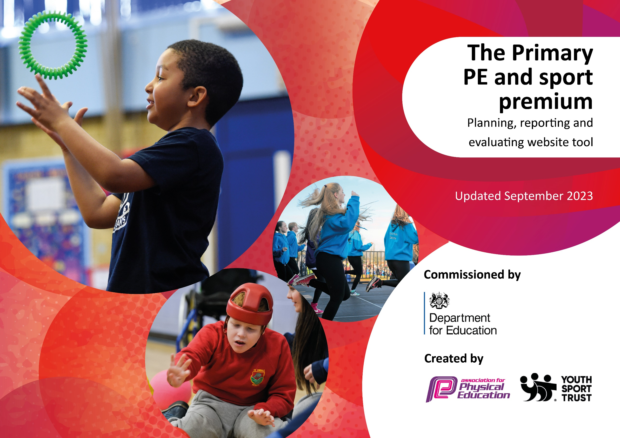

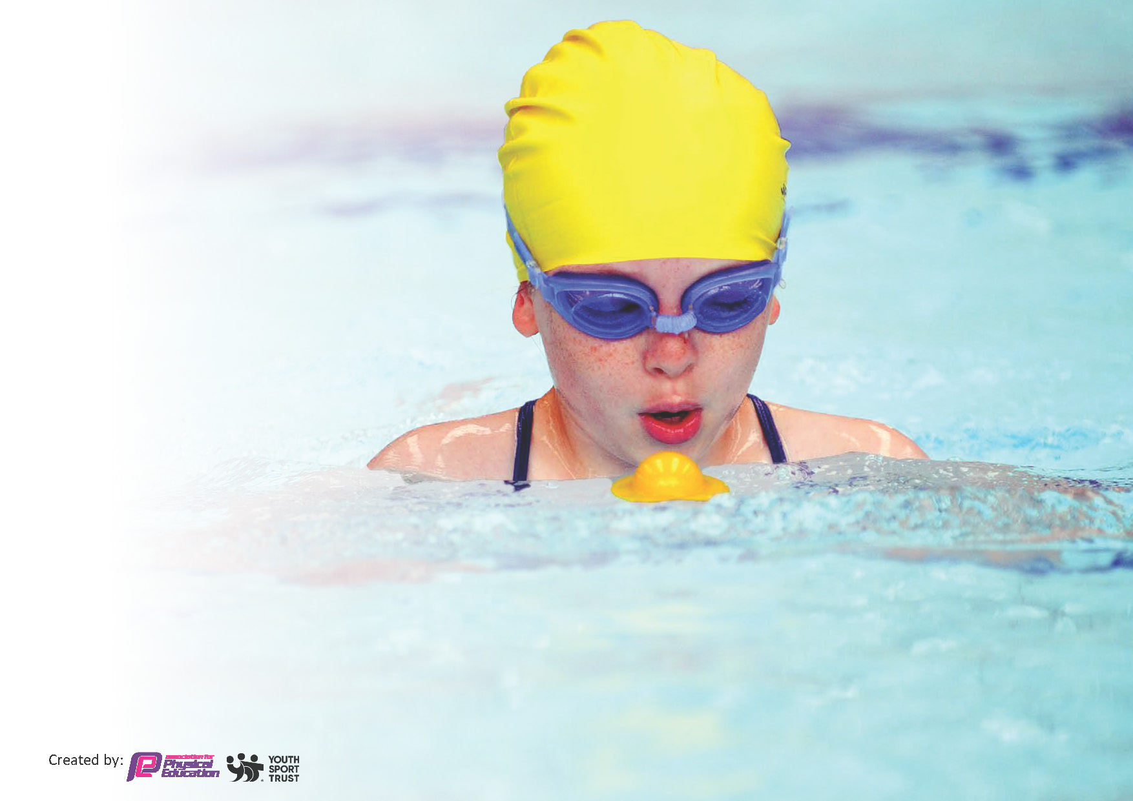
This template can be used for multiple purposes:
by:
- It enables schools to effectively plan their use of the Primary PE and sport premium
- It helps schools to meet the requirements (as set out in guidance) to publish information on their Primary PE and sport premium
- It will be an effective document to support Ofsted inspections enabling schools to evidence progress in Physical Education (PE) and evidence swimming attainment, which forms part of the PE National Curriculum. We would recommend schools consider
the Intent, Implementation and Impact of any spend, as examined within the Education Inspection Framework.

It is important that your grant is used effectively and based on school need.

Schools must use the funding to make additional and sustainable
improvements to the quality of the PE, School Sport and Physical Activity (PESSPA)
they offer. This means that you should use the Primary PE and sport premium to:

- Build capacity and capability within the school to ensure that improvements made now will benefit pupils joining the school in future years
- Develop or add to the PESSPA activities that your school already offers.

The Primary PE and sport premium should not be used to fund capital spend projects; the school’s core budget should fund these. Further detail on capital expenditure can be found in the updated Primary PE and sport premium guidance.

The Primary PE and sport premium guidance, outlines 5 key priorities that funding should be used towards. It is not

necessary that spending has to meet all the key priorities, you should select the priorities that you aim to use any funding towards.

Although completing this template is not a requirement for schools, schools are required to publish details of how they spend this funding. Schools must also outline what the impact this funding has had on pupils’ PE and sport participation and attainment and how any spending will be sustainable in the future. All funding must be spent by 31st July 2024.

The Department for Education has worked closely with the Association for Physical Education (afPE) and the Youth Sport Trust (YST) to develop this template and encourages schools to use it. This template is an effective way of meeting the reporting requirements of the Primary PE and sport premium.
Review of last year’s spend and key achievements (2022/2023)

Activity/Action | Impact | Comments
The children were provided with a PE curriculum which allowed them to develop their knowledge, skills and understanding of a range of sports. They learnt about the importance of a healthy lifestyle and being active.  Additional sports equipment was purchased for use in ‘free time’ e.g. lunchtimes etc. | All the children had access to x2 1 hour PE lessons a week. 1 hour taught by a PE specialist and 1 hour by a trained Class Teacher.  Children had the opportunity to play with hoops, beanbags, skipping ropes during lunchtimes etc. | Children took part in sports such as hockey, lacrosse, tennis, swimming etc.  Children were observed playing either alone or in groups at lunchtime.

Key priorities and Planning

Action – what are you planning to do | Who does this action impact? | Key indicator to meet | Impacts and how sustainability will be achieved? | Cost linked to the action
Children will have access to 2 hours quality PE a week. 1 hour taught by a specialist and 1 by the Class Teacher.  All children to have the opportunity to take part in at least one Inter House competition throughout the year.  All children to have the opportunity to take part in Enrichment activities across the school year. These include both Class events and whole school. | All children as they will have the opportunity to be active and to learn the skills of different sports.  All children throughout the school.  All children throughout the school. | Key indicator 2 -The engagement of all pupils in regular physical activity – the Chief Medical Officer guidelines recommend that all children and young people aged 5 to 18 engage in at least 60 minutes of physical activity per day, of which 30 minutes should be in school.  Key indicator 4: Broader experience of a range of sports and activities offered to all pupils.  Key Indicator 1- Increasing all staff’s confidence, knowledge and skills in teaching PE and sport.  Key indicator 5- increase participation in competitive sport.  Key indicator 4- offer a broader and more equal experience of a range of sports and physical activities to all pupils.  Key indicator- 3 raising the profile of PE and sport across the whole school, to support whole school improvement. | More pupils meeting their daily physical activity goal, more pupils encouraged to take part in PE and Sport Activities.  Primary teachers more confident to deliver effective PE supporting pupils to undertake extra activities inside and outside of school, including teaching water safety and swimming and as a result improved % of pupil’s attainment in PE.  Children to participate and to be made aware of sports that they might otherwise not know about or consider.  Children to have fun trying different sports. | Cost of Premier education. - £7,215  Bus hire- to inter school events - £1,901  Cost of Enrichment events- Term 1 Lacrosse/ Balanceability = £770, Term 6 Archery/Golf = £770 plus Eiffel Tower Olympic Day = £425

Key achievements 2023-2024

Activity/Action | Impact | Comments
All year groups will have had the opportunity to take part in a variety of different sports across the year taught by specialist coaches including hockey, tennis, athletics etc.  All children in Years 3 and 5 took part in a block of 6 sessions of swimming. Children in Years 4 and 6 have taken part in a black of 7 sessions of swimming.  Children in EYFS have taken part in 6 weeks of Balanceability sessions.  Year 5 took part in the Bikeability sessions and gained Level ½ cycling proficiency awards.  Children in Years 1 and 2 took part in a block of Lacrosse sessions  Children in Years 3 to 6 took part in a block of 7 sessions of archery/golf sessions.  Children in Years 1 to 4 have had the opportunity to take part in an Inter school’ sport competition.  Children in Years 5 and 6 have had the opportunity to take part in a cricket and rounders tournament.  A group of girls took part in the ‘Let Girls play football’ event.  The whole school has had an Enrichment Day based on the Paris Olympics.  Year 5 and 6 took part in a Dance project run by the Royal Opera House. This involved a theatre visit and a workshop. | Children have had the chance to regularly exercise and to look forward to taking part in sport.  Children were taught to swim by qualified instructors.  Children learnt how to use the Balance bikes.  Children in Year 5 have an understanding of safety on the road and how to use their bikes safely.  Children enjoyed trying different sports and learnt new skills.  Children have learnt how competitive competitions work.  Girls realised that football opportunities were available to them.  Children enjoyed the day competing for their different houses and were exercising throughout the day.  Children had the opportunity to see how quality dance.

Swimming Data
Meeting National Curriculum requirements for swimming and water safety.
Priority should always be given to ensuring that pupils can perform safe self-rescue even if they do not fully meet the first two requirements of the National Curriculum programme of study

Question | Stats: | Further context  Relative to local challenges
85% of the Y6 pupils can swim confidently a distance of 25m or more. | 85% | The pool that the school use is 25 minutes’ drive away by coach and the school have limited slots there. Therefore, the school have to take 2 6-week blocks of time at the pool.
85% of the pupils can swim a range of strokes e.g. front crawl, backstroke etc. | 85% | Years 3 to 6 (24-25) will continue to swim next academic year.

85% of pupils are able to complete a water rescue. | 85% | Practice of this skill is limited due to the amount of time that is available for swimming.
If your schools swimming data is below national expectation, you can choose to use the Primary PE and sport premium to provide additional top-up sessions for those pupils that did not meet National Curriculum  requirements after the completion of core lessons. Have you done this? | No
Have you provided CPD to improve the knowledge and confidence of staff to be able to teach swimming and water safety? | No | Swimming instructors were employed at the pool we use.

Signed off by:

Head Teacher: | Z. Longstaff
Subject Leader or the individual responsible for the Primary PE and sport premium: | Z. Longstaff- Head Teacher/PE lead
Governor: | L. Warman
Date: | 19.07.24

