
Swinderby All Saints Primary School
Governor Finance Report – October 2024
Financial Plan for 24/25
As predicted, the Monitoring and Intervention plan has been triggered again following us ending with a deficit in 23/24 and submitting a continuing deficit budget in future years. No requests for up to date plans from School’s Finance as yet. Internal monitoring is going on in school as much as possible and forecasts have commenced. These have been submitted in September and another at the beginning of October. Our next scheduled meeting with School’s Finance, as part of the silver package, is 31.01.2025.
Governor Approved – 14.05.2024

Deficit at the end of 23/24 Deficit at the end of 24/25
Deficit at the end of 25/26
There have been some significant changes since the plan was approved in May, including the following:
- Teacher pay increase has been agreed at 5.5% (this was an increase from the 4% that LCC had budgeted for)
- Funding to help cover some of this increase has been received. This is called the Core Schools Budget Grant (CSBG) and gave us an additional £6992
- The TA who’s 1:1 left at the end of July originally had her contract reduced to 27.5hrs per week. Since starting back in September, it was discovered that the classroom she was working in was short of staff (due to other 1:1 needs) when she left so her hours have been increased to 30.40mins per week
- Higher needs funding was slightly out – the Notional funding was £500 less than what was showing on the MTFP. Plan amended to show correct values. All other Higher Needs income was correct
- The Scheme for Financing Schools section 5.4 & 5.7 states schools with a surplus budget share balance will earn interest and schools with a deficit balance will be charged interest – therefore we have had an additional £1,517.88 charged to us. This is calculated by deficit budget at the start of 23/24 + deficit budget balance at the end of 23/24 divided by 2 x by the Bank of England base rate plus 2% (therefore 7.03%)
- Resignation of a TA who will leave at half term. Their contract was 13 hours per week. We think we may have managed to replace with existing staff members but only require 6 hours per week giving us a cost saving.
- Reduced the amount of income from Cabin Club (Breakfast and Afterschool) and demand has gone down for this.
- Breakfast Club worker on a Tues, Wed and Friday has handed in her notice and will leave at half term. We have advertised internally for a replacement but no-one has come forward. We have also looked at outsourcing the entire BKC/ASC to Premier Education but they have advised that to make it work for them they’d need a minimum of 15 children every session, something we cannot guarantee. No amendments to plan as yet until we know how this will be covered.
- Breakfast Club worker is also a cleaner 2 mornings per week, this has been taken up by the other cleaner and this has given us a slight saving by having 1 less person on the staff roll.
- We have employed a new Relief MMSA due to on-going staff absence. This is logged in the MTFP at a 6.25 hour contract.
With these adjustments the budget now looks as follows:
Deficit at end of 24/25
Deficit at the end of 25/26
The in-year position for 24/25 is -£41,698 meaning we would have ‘paid back’ this amount against our deficit from 23/24.
Graphs
The following graphs have been taken from the MTFP Dashboard.
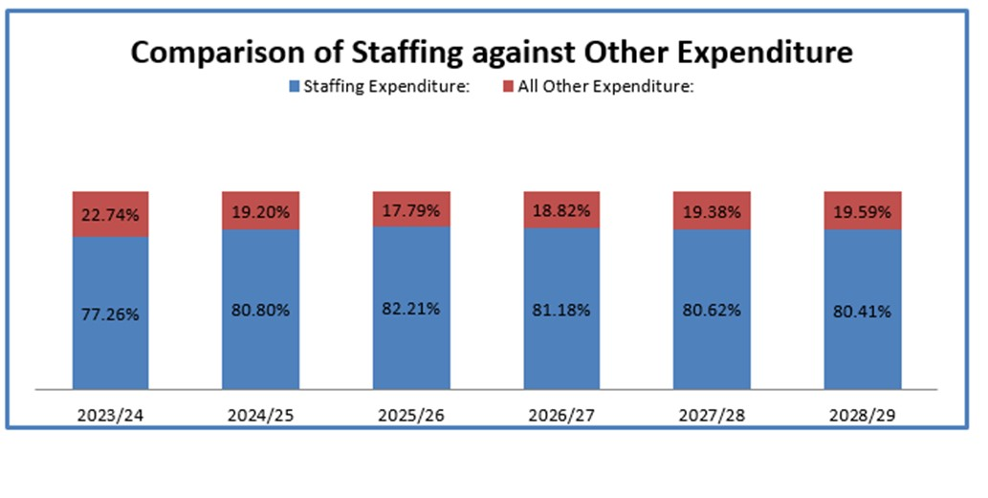
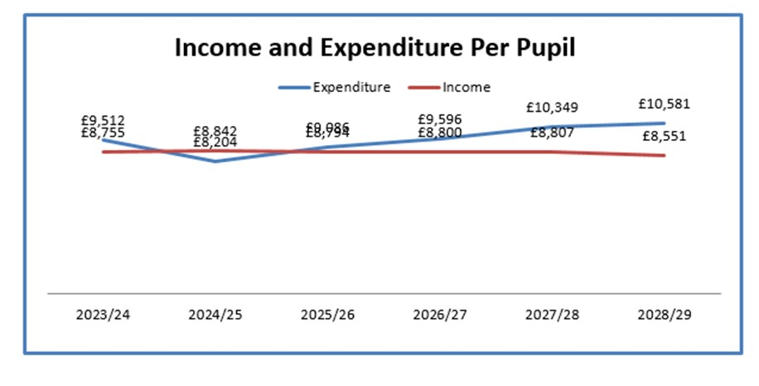
Summary Page
Pupil Numbers
We have had several mid-year admissions and one child returning from EHE which has meant our numbers have increased from the predicted 75 to 79. This number has been recorded in the October census which was submitted on the 03.10.24. We have also accepted another Y4 midyear admission. They’re moving to Witham from Lincoln but the house isn’t ready yet so I haven’t been able to add them to our roll in time for the census. Hopefully, this will mean we’ll be back up to 80 children.
Teaching Staff
Any pay increases & overtime for teachers have been built into the plan
Non-Teaching Staff
Any pay increases & overtime for support staff have been built into the plan.
Grants
Grants have been utilised, where possible, to take the pressure off the main budget. Future years still need work for some of the grants.
Audit
ZL and TS were notified by LCC that an audit is due and following a lengthy Teams call it was advised that due to a shake-up of LCC’s Audit team ALL schools will receive an audit. Because we requested an audit back in 2018 (when ZL and TS took position) we were flagged up first. The audit will take 6 days in total, 3 off site and another 3 in school, when the auditors (3 of them) are in school they will need ZL and TS available at all times. The audit will cover areas including but not limited to the following:
- Governance Arrangements: Governing Body, Key Policies; Meeting Minutes, SoD
- Budget Preparation, Monitoring, Forecasting and Reporting
- MTFP submission to Schools Finance plus submission email
- If a deficit budget has been set – approval from Children’s Services Financial Advisor
- HR procedures - including a review of HR Files, induction and probation procedures and contract issuance timing
- Finance procedures - including Procurement/Credit card information/process and reconciliation, Sales Orders outstanding in debtor information, School Fund mandate, reconciliation and audit, Paying in books for school fund and LCC bank account, Receipting book & processes including lettings, Travel/expenses & additional hours claims, Quotes for contract/purchases over £10K.
Another Teams meeting is booked for 08.11.24 and it will be confirmed what information the auditors need ahead of them coming into school w/c 25.11.24. There is a charge for this audit (included in the MTFP) and this will be £2,822. As we’re in a deficit budget we will be able to pay this in instalments over 3 years (equating to £940/an). There will be 4 ratings: No Assurance, Low Assurance, Adequate Assurance and Substantial Assurance. Substantial is unlikely (apparently). If we get Adequate we won’t need auditing again for 3 years and it will be a rolling 3 year programme. Anything lower, that it will be a yearly follow up. IL is already aware of this audit, as access to Governor Documents will be required.
Preschool
Marketing is continuing and our first Stay and Play session saw 3 children attend (a 4th was due but parent unwell). School’s Finance – Lizzie Bowes – asked for a Business case to be put forward as TS questioned what it would mean for us with a deficit budget. The Early Years Team had said that making a loss at first was almost guaranteed until our numbers/sessions increased. This Business Case was submitted on 23.09.24 but nothing has been heard since.
Devolved Capital
New lights have been fitted throughout school during the summer holidays. The cost of these lights came in more than expected as one classroom had been missed off the original survey (and therefore the quote) and the work took 2 days longer than anticipated. Still fully funded from Devolved but does mean our budget for 24/25 is smaller than we thought.
School Fund
The 2023-2024 account is due for auditing again and this is being done in December in time for submission to the Charity Commission by 31.01.2025.

