
Swinderby All Saints Church of England Primary School

Governance Update

Forename | Surname | Nature of Office | Appointed | Term End | Inst of Gov
Lynne | Carter | Co-opted | 10/02/2018 | 09/02/2022 | 2 of possible 2
Sue | Marris | Co-opted | 19/12/2018 | 18/12/2022 | 2 of possible 2
Laura | Warman | Parent | 01/03/2020 | 28/02/2024 | 3 of possible 4
Hallie | Whitton | Parent | 30/11/2021 | 29/11/2025 | 3 of possible 4
Heidi | Adams | Parent | 02/07/2021 | 01/07/2025 | 3 of possible 4
Alison | Hul | Staff | 22/01/2020 | 21/01/2024 | 1 of possible 1
Zoe | Longstaff | Headteacher | 01/09/2018 | Ex officio | 1 of possible 1
Vanessa | Laird | LA Nominated | 14/12/2017 | 13/12/2021 | 1 of possible 1
Andrew | Vaughan | Foundation | 26/04/2018 | Ex Officio | 2 of possible 2
Gill | Lloyd | Foundation | 15/01/2018 | 14/01/2022 | 2 of possible 2

To note/decide: Vanessa’s nomination has been put to LCC and we are hoping that their agreement to her nomination will be issued in time for the December meeting, so this can be put to the meeting for formal approval.
To note: The Diocesan Board for Education has been advised that Gill wishes to stand for another term of office. We are awaiting their confirmation on this.
To note: Anna Tarrant resigned, as expected, following the last meeting. An invitation for nominations was issued to parents and Ms Hallie Whitton has volunteered for the role.
To note: We therefore have just one vacancy, for a parent governor.

Governor Monitoring Reports 2020-21

To note: Detailed at appendix 1. This list the monitoring reports received by governors during the last year. This is published on the school website.

Register of Interests 2021-22

To note: Detailed at appendix 2. Ms Whitton’s details will be added soon. This is published on the school website

Skills Audit Forms

To action: Members are just reminded that forms (email dated 11/11/21) need to be sent to the Clerk before the end of term so she can work on a training matrix in time for the spring meeting.

Governors Networking and Training
Action: This session is the second in a series of training designed to support your role as governors in a Church school.

Book in for all 4 for £200pp or £60pp per session for SLA schools.
Clergy £35pp per session.
Session 2 Strategic Vision

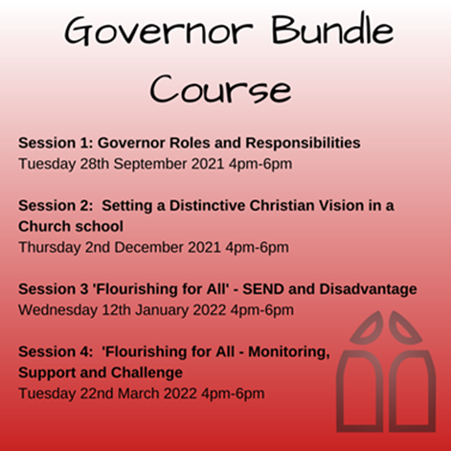
This session will scrutinise the responsibility of governors to set the strategic direction of the school. It will consider what it means to have a ‘distinctively Christian’ strategic vision, as well as considering practical approaches to monitoring the effectiveness of the school as a church school.
To book please click on the link below:

https://www.lincolndiocesaneducation.com/calendar/?calid=1,2,3,4,5,6,7&pid=9&viewid=1&event=183

You will need to book on each date separately, you will not be automatically booked on all sessions.

Appendix 1: Governor Monitoring Reports 2020-21

The following reports were considered by the governors during the 2020-21 year.

 | Autumn Term | Spring Term | Summer Term
Finance Team | - 2 Finance Team reports | - 2 Finance Team reports | - 2 Finance Team reports
Provision | - Key Stage 1  - Key Stage 2 | - Key Stage 1  - Key Stage 2 | - Walk about School  - Maths and Literacy
SEND and Inclusion |  | - Meeting with SENDCo  - Meeting with Emotional Literacy Support Assistant
Lockdown |  | - Impact
Safeguarding |  | - Update Report
Health and Safety |  |  | - Accessibility
Staff Welfare |  |  | - Teachers  - Teaching Assistants across all years  - Caretaker  - Administration staff  - Cabin Club staff  - Midday staff

Appendix 2: Declaration of Personal Interest Year 2021-22

 |  |  | Category of Governorship | Signed Annual Declaration | Relevant Business Interests | Links to Other Educational Establishments | Personal relationships | Date declared
Ms | Heidi | Adams | Parent | 14/09/2021 | None | Kesteven and Grantham Girls School | None | 14/09/2021
Mrs | Lynne | Carter | Co-opted | 02/08/2021 | None | None | None | N/A
Ms | Alison | Hul | Staff | 02/09/2021 | None | None | None | N/A
Ms | Vanessa | Laird | LA Nominated | 21/09/2020 | None | None | None | N/A
Ms | Gil | Lloyd | Foundation | 20/07/2021 | None | None | None | N/A
Mrs | Zoe | Longstaff | Headteacher | 21/07/2021 | None | None | None | N/A
Dr | Sue | Marris | Co-opted | 20/07/2021 | None | None | None | N/A
Rev | Andrew | Vaughan | Foundation | 21/07/2021 | Son - Chris Vaughan Photography - potential provider of photographic services to the school | Thorpe St Michael's - Local Priest |  | 07/07/2020
 |  |  |  |  | Diocese of Lincoln – Priest in Diocese |  |  | 21/07/2021
 |  |  |  |  |  | Thorpe St Michaels - local Priest |  | 07/07/2020
 |  |  |  |  |  | Eagle Community Primary - local Priest |  | 07/07/2020
 |  |  |  |  |  | North Scarle Primary - Governor |  | 21/07/2021
Ms | Laura | Warman | Parent | 21/09/2021 |  | Employee of Meden School |  | 30/08/2020
Ms | Anna | Tarrant | Parent | 07/09/2021 | None | University of Lincoln | None | 07/09/2021

