Head Teacher’s verbal report. Thursday 19th May 2022
Key headlines
3 classes are in place in school
Y4 teacher in place mornings only for English and maths- from Jan 4th to March 31st. I teach Y6 on a Monday morning and support with EHCP at certain points of the week.
76 children on roll:
Class 1 R/1- 21
Class 2- 2/3- 25 (incl. x1 Y4 who needs extra support)- 13 in Year 4 class am
Class 3- 4/5/6- 30
We currently have x3 children with EHCPs.
Attendance up to Friday 06 May 2022.
C1 – 95.26%
C2 – 95.96%
C3 – 98.47%
School – 95.59%
National – 92.6% (up until 29.04.22)
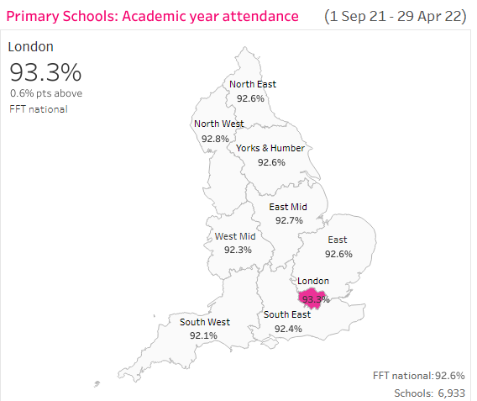
The SDP is being followed. Subject leads all continue to work with this and follow the Monitoring/ Assessment plan.
The curriculum is in place and operating well. Read, Write, Inc is being embedded across school and a Development Day was held with the RWI consultant and Mrs Hul. EYFS data was submitted December 2021 to County.
Subject leaders continue to use subject leadership days to carry out their roles. They have successfully completed their 1:1 session with Leann Lynch with huge progress being reported.
20 children have successfully completed a 6 week intervention programme for reading – x30 mins a day. This has been funded through Recovery funding topped up with Catch Up funding. School led tutoring has been running for 11 children a week over 8 weeks.
Mrs Lill has begun her National Professional Qualification in Leading Teachers -NPQLT. The work she is doing will contribute to continued school improvement.
Governors have carried out monitoring visits including: Safeguarding, Health and Safety, Pupil Premium and Covid Catch up money, Quality of Education, Finance.
Behaviour and attitudes
ALL staff are modelling good behaviour and attitudes to learning. We have talked about living out the school values and Vision. Celebrations assembly is held every Friday.
High work expectations are being set. Upon visiting the classrooms- good teaching is being seen. This was commented upon by Tamsin Caputa.
Personal Development
Various clubs are back up and running including choir, booster and MSP. The mini-Police and Junior Road Safety officers are active carrying out community work or leading assemblies in school.
Leadership and Management
Support staff performance development meetings have been held.
A second core meeting is being held with Tamsin Caputa/Sue Marris on Jan 25th. Tamsin has visited in January and looked at progress against the SDP.
The Kyra Peer review partnership has been joined to aid school self-improvement. Mrs Hul is undertaking a peer review at Kirkby on Bain Primary School on Tuesday 25th January.
Provision for EYFS
X1 LAC child joined EYFS last week.
A joint visit between Helen Rutherford Early Years support and Tamsin is planned in the next few weeks.
Staffing
Hannah Colclough has had some extra training for writing and a joint scrutiny of Y2 and Y6 writing was carried out by myself and Catherine Caldwell.
AOB
The school has 11 first choice applications for Sept 22 including some children choosing Swinderby over Witham St Hugh’s.
A fact-finding visit is booked next week for myself and Sue to look at eagle pre-school.
Class 2 have a new interactive whiteboard.

