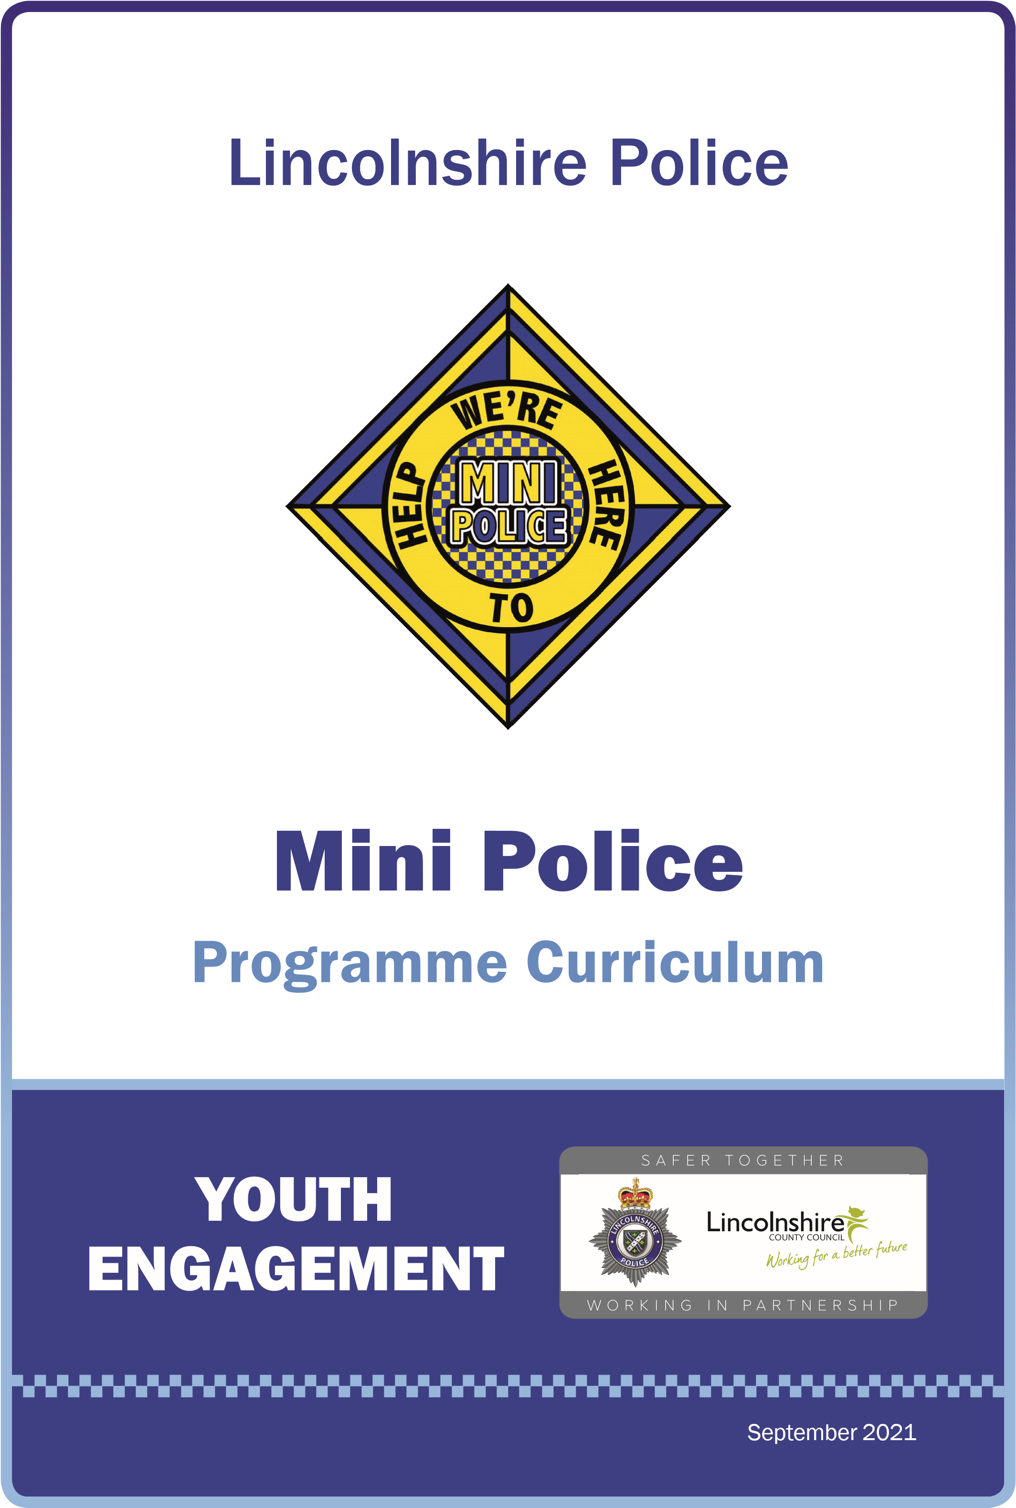
September 2022

MINI POLICE
Mini Police is a community cohesion project that has been running successfully in primary schools across Lincolnshire since September 2018.
With an unscheduled COVID break in schools the programme was refreshed and edited for its September 2021 relaunch.
It is a 12-lesson engagement programme delivered to primary-aged children, predominantly years five and six (ages 9-11). Some engagements can be delivered as full school activities.
The programme runs for two years and will mostly be delivered by local Police Community Support Officers (PCSO) to enable familiarity, local knowledge, and confidence in the local policing teams. It has been designed around the concept of pupil voice, so each school has a relevant and impactive experience.
Mini Police Lincolnshire has been aligned to the national Personal, Social, Health and Economic Education curriculum as it focuses on children’s personal development, which helps them be more confident, resilient, independent and develop character. It also helps them to assess and challenge age-appropriate risky situations.

PROGRAMME DETAILS
You will be allocated a PCSO who will be your consistent facilitator throughout the programme. All facilitators will work with your school to ensure that all guidance and measures you have in place are adhered to.
The main change of the refresh of the programme, post Covid-restrictions, is that any child in your school can be a mini police officer, the nominations process of old have been replaced by a simple application process to allow all to achieve. This has been reflected in the costs associated to the programme and a reduction in the uniform. Any uniform that the school has can still be used however moving forward, this will be much simpler with a cost per child of £7.25. We also have new, large, Mini Police banners available to display outside your school at £15 per banner as well as pupil Mini Police coats at the cost of £32.50 each. Please speak to the Youth Engagement Team or your Mini Police Facilitator if you would like to order any additional items.
The £7.25 cost per Mini Police Cadet includes; Draw String Bag, Mini Police Baseball Cap, Lanyard with lesson/learning cards, Pen, ruler, notebook & pencil. At the end of the individual pupil’s engagement, they will be able to keep the lanyards, stationary, bag and baseball cap.

PROGRAMME SYNOPSIS
•
Police engagement programme for children aged 9-11 years (Upper KS2) with
benefits for the entire school and surrounding communities. Creating ambassadors for the
individual schools, Local Communities and Lincolnshire Police with an element of career
building.
•
A community cohesion project that embodies the community engagement targeting
schools with a high proportion of disadvantaged children or schools in low visible policing
areas with minimal police interaction.
•
Falls in line with local and national crime prevention priorities concentrating on local and
national aims.
•
Supports schools with elements from the personal, social, health education (PSHE)
spiritual, moral, social and cultural (SMSC) and Fundamental British Values (FBV)
education curriculum.
•
The programme works with the citizens in policing, working in partnership
with schools and partner agencies.
•
Designated Lincolnshire Police staff offering support in all areas of Lincolnshire initially at
100
primary schools.

PSHE COVERAGE
Schools must offer education programmes that give support for pupils to thrive in a period of
rapid change with new and unpredictable opportunities and challenges. To do this schools
should take learning opportunities from three core themes within the PSHE programme:
Health and wellbeing, relationships and living in the wider world. The Mini Police Programme
will assist schools in offering coverage within these themes.
“PSHE education supports academic success, says major evidence review
•
Very strong evidence that PSHE learning has a positive impact on academic attainment,
according to independent pro bono economics review.
•
Disadvantaged pupils enjoy greatest benefits to academic performance
•
Through its proven impact on physical and mental health, levels of bullying and general
behaviour, PSHE education removes barriers to learning and develops skills that help
young people exceed.
•
PSHE association urges government to follow through with proposals to make PSHE
statutory, in line with other subjects, to ensure all pupils benefit.”
(
PSHE Association, Pro-Bono Economics,
2017)

PROGRAMME OF STUDY

- Identity (their personal qualities, attitudes, skills, attributes and achievements and what influences these; understanding and maintaining boundaries around their personal privacy, including online).

- Relationships (including different types and in different settings, including online).

- A healthy (including physically, emotionally, and socially), balanced lifestyle (including within relationships, work-life, exercise, and rest, spending, and saving and lifestyle choices).

- Risk identification, assessment and how to manage risk (rather than simply the avoidance of risk for self and others) and safety including behaviour and strategies to employ in different settings, including online in an increasingly connected world.

- Diversity and equality (in all its forms, with due regard to the protected characteristics set out in the Equality Act 2010).

- Rights (including the notion of universal human rights), responsibilities (including fairness and justice) and consent (in different contexts).

- Change (as something to be managed) and resilience (the skills, strategies and ‘inner resources’ we can draw on when faced with challenging change or circumstance).

- Power (how it is used and encountered in a variety of contexts including online; how it manifests through behaviours including bullying, persuasion, coercion and how it can be challenged or managed through negotiation and ‘win-win’ outcomes).

- Career (including enterprise, employability, and economic understanding).

PROMOTING BRITISH VALUES AS PART OF SMSC IN SCHOOLS

As of 2002, schools, as part of a broad and balanced curriculum, have to promote the spiritual, moral, social, cultural, mental and physical development of pupils at the school and of society. British Values actively promotes the values which looks at challenging opinions or behaviours in school that are contrary to fundamental British Values. Through the Mini Police programme, we can help with the following:

- Enable students to develop their self-knowledge, self-esteem and self-confidence.

- Enable students to distinguish right from wrong and to respect the civil and criminal law of England.

- Encourage students to accept responsibility for their behaviour, show initiative, and to understand how they can contribute positively to the lives of those living and working in the locality of the school and to society more widely.

- Enable students to acquire a broad general knowledge of and respect for public institutions.

- Further tolerance and harmony between different cultural traditions by enabling students to acquire an appreciation of and respect for their own and other’s cultures.

- Encourage respect for other people.

- Encourage respect for democracy and support for participation in the democratic process, including respect for the basis on which the law is made and applied in England.

- An understanding of how citizens can influence decision-making through the democratic process.

- An appreciation that living under the rule of law protects individual citizens and is essential for their wellbeing and safety, for example – The Prevention Strategy 2011

- An understanding that there is a separation of power between the executive and the judiciary, and that while some public bodies such as the police and the army can be held to account through Parliament, others such as the courts maintain their independence.

- An understanding that the freedom to choose and hold other faiths and beliefs is protected in law.

- An acceptance that other people having different faiths or beliefs to oneself (or having none) should be accepted and tolerated and should not be the cause of any prejudicial or discriminatory behaviour.

- An understanding of the importance of identifying and combatting discrimination.

- Ensure that all pupils within the school have a voice that is listened to, and demonstrate how democracy works by actively promoting democratic processes such as school council whose members are voted for by the pupils – Pupil Voice
- Roles of extracurricular activity, including any run directly by pupils, in promoting fundamental British values are in place.

LINCOLNSHIRE POLICE RESPONSIBILITIES

The Mini Police programme will be delivered to upper Key Stage 2 with breakout groups of pupils from Years 5 and 6 for the seconds session.

In total the breakout groups will be a maximum of 10 pupils.

Selection will go ahead every September to engage new Year 5 students.

The pupils will be offered guidance and taught subjects relating to Crime Prevention along with Lincolnshire Police initiatives that would be both useful and impactive.

The children will be given the tools to feedback to their peers and communities through the platform of blogging, posters, assemblies, statistics, graphs and conversations in person. A few topics within the programme would be able to be delivered to the whole school community, For example Safe Strangers.

- Initial school contact

- Welcome talk/Ambassador selection with year 5/6 (if year one of the programme) includes police talk (2 hours)

- Elections and uniforms

Programme start:
Sessions will be booked in for the full academic year prior to the start of the school year in September, or as close to the start of the year as possible to ensure dates are agreed for the year ahead and to give the school plenty of notice to prep for the engagements.

Please note: PCSO’s are not expected to manage behaviour during the session. It is essential a member of appropriate school staff is present during the session to support with this.

SCHOOLS RESPONSIBILITIES

•
To assign a single point of contact (SPOC) within the school to be responsible for a noticeboard and
presentation folder to document past engagements displayed in a prominent location in
the school.
•
Allow the Mini Police Team to actively carry out their role even when not in company with
the member of Lincolnshire Police staff and support all parts of the engagement.
•
Regular liaison between the school point of contact and the designated Lincolnshire Police
SPOC to address issues.
•
Mini Police uniform is the property of the school and each school must maintain and replace
when required at the school’s expense.
•
Allow an annual evaluation and feedback to the local Mini Police programme in line with
the Child Centred Policing Policy.
•
Allow the sharing of the school’s code of conduct/behaviour policy to the Mini Police
facilitators to ensure that we are following the same guidelines per individual school.
•
Schools are responsible for children’s individual risk assessments and details of any heath
conditions if the child is part of the programme.
•
Schools should advise the Lincolnshire Police representative if a child does not have
permission for photograph and internet use in line with the current procedures.
•
If a child on the programme has additional needs, risk assessments and educational
healthcare plans, this will be taken into consideration which might include the need for an
extra member of staff or restricted external visits.
•
Schools are required to provide dates for the Mini Police engagements for the full
academic year.
AMBASSADOR SELECTION
To nominate the School/Academy and Lincolnshire Police Ambassadors for the Mini Police Team. Every student who expresses an interest in becoming a Mini Police Ambassador should be given the opportunity within the 2-year programme.

The programme can be delivered with a minimum of 4 mini police officers with no maximum number, as-long-as the school are able to facilitate a rolling programme, so that there are only 10 mini police officers at any one-time taking part in each engagement with the PCSO officer.

Programme Plan

All Upper KS2

The Mini Police Facilitatory will attend the school (year 1 of the programme) and hold a class discussion with all year five and six students, if the second year of the programme, only year five. Explain the programme and how the students can get involved. After the initial talk, the children who have expressed an interest will be given one week to prepare their application. This can be in any form they wish, such as, an application form, pre-recorded speech, vlog, cartoon, poem etc. The application must demonstrate the following skills to be successful:
• Uphold good behaviour
• Be an ambassador for Lincolnshire Police, the school and the local community
• Work towards all pupils respecting one another
• Look to address problems or conflicts within the school whilst working collaboratively with teachers
• Distribute advice and share information to pupils, parents and members of the community

Full School Engagement

Schools will be encouraged to select the appropriate applications based on the skills and qualities below.
• Uphold good behaviour
• Be an ambassador for Lincolnshire Police, the school and the local community
• Work towards all pupils respecting one another
• Look to address problems or conflicts within the school whilst working collaboratively with teachers
• Distribute advice and share information to pupils, parents and members of the community
• Recognise and promote kindness

The ideal scenario will be that the school council or other pupil led discussion groups will decide which students are selected to represent the school.
Schools are to liaise with the PCSO to let them know who has been selected and when the celebration assembly will be so that the PCSO can attend and award the mini police officers with their uniform.

Within this engagement all mini police officers will be invited to the front of the class or hall to be sworn in using the mini police ambassador promise, featured on the lanyard card. At this time all ambassadors will be given their uniform which consists of a Bag, Cap, Lanyard and cards, Note-Book, Pen, Pencil and Ruler. This is a celebration of their selection and for the rest of the school to identify who have been assigned as a Mini Police Officer.
MINI POLICE RESPONSIBILITIES
•
Uphold good behaviour
•
Be an ambassador for Lincolnshire Police, the school and the local community
•
Work towards all pupils respecting one another
•
Look to address problems or conflicts within the school whilst working collaboratively with
teachers
•
Distribute advice and share information to pupils, parents and members of the community
•
Recognise and promote kindness
HEALTH AND SAFETY
•
In compliance with the Health and Safety at Work Act 1974 and all other relevant health
and safety policies and procedures both parties (Lincolnshire Police and the participating
school) will adhere to such policies. With prior agreement either party may have the access
to the other health and safety records, including risk assessments to ensure transparency
and the safety of all concerned.
•
In relation to insurance, those events held within school time will be covered by the
participating school, usually through their service level agreement with the local Education
Department, or through separate cover arranged by the school/academy. Any event held
outside of normal school hours will be covered by the event organisers Public Lability
Insurance.
SAFEGUARDING
•
All staff and volunteers will be vetted or have completed the enhanced disclosure
application process.
•
The school accepts that they are responsible for the relevant risk assessments in relation
to school visitors and educational visits.
•

If a child, whilst involved in an engagement, makes a disclosure to the designated Mini
Police contact for that engagement, they will inform the school designated safeguarding
lead as soon as possible for them to follow the correct safeguarding procedures relevant
to the risk. If out of school hours, where the school is not available, normal policing rules
apply including speaking to on-duty supervisors or the public protection unit this will also
include completion of relevant Stop Abuse forms. Schools to be notified at the earliest
opportunity for their own safeguarding records through the safeguarding lead.
•
Lincolnshire Police retains the right to act on any information given to them in accordance
with legislation and/or force guidelines such as intelligence.
•
The Mini Police programme understands Schools and Academy’s take safeguarding
seriously and we will work together to safeguard and promote the welfare of children within
the programme.
EVALUATE POST INITIATIVE
To evidence impact and engagement individual schools could document within their school
websites, display on notice boards, presentation folders and latest news including pictures
and information about engagements along with relevant SMSC, FBV, and PSHE headers.
Lincolnshire Police could provide a learning objective slip to affix to exercise books that could
be completed with the relevant engagement. We appreciate all schools are different in how
they document but we could assist with ideas where necessary. All schools will be given a
questionnaire prior to the programme and be asked for regular feedback.
Each engagement would be documented on various twitter and social media accounts with
the relevant hashtags @lincspolice @MiniPoliceLincs and the individual school account along
with the potential of the wider audience.
LINCOLNSHIRE POLICE FORCE VALUES
Each school will have their own school ethos and behaviour policy which we understand is at
the heart of all work in schools. We will also be led by Lincolnshire Police force values:
We are Courageous, Open, Fair, and Inclusive.

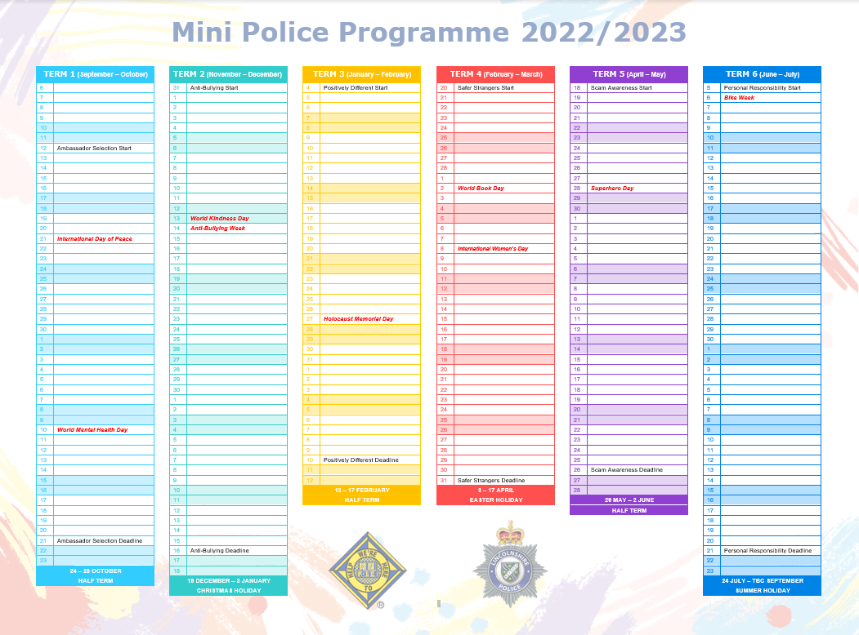
Module Durations

Each session will have a 1-hour delivery time to present to all of year 5 and 6
(using session plan and/or PowerPoint) and then a separate engagement with just the Mini Police Ambassadors (Depending on session).

All sessions, including the Ambassador assembly is to be delivered by a trained PCSO.
The Mini Police Ambassadors must not be delivering the Mini Police sessions to their peers.

Module | Session 1 | Session 2
Ambassador Assembly | 1 Hour  All Year 5 and 6 | 30 Mins max  Full School Assembly
Random Acts of Kindness | 1 Hour  All Year 5 and 6 | 1 Hour  Mini Police Team
Fatal 4* | 1 Hour  Mini Police Team | 1 Hour – Community Engagement  Mini Police Team
Digital Resilience** | 1 Hour  All Year 5 and 6 | 1 Hour  All Year 5 and 6
A Diverse World | 1 Hour  All Year 5 and 6 | 1 Hour  Mini Police Team
Crime Prevention* | 1 Hour – Community Engagement  Mini Police Team | 1 Hour  Mini Police Team
Anti-Social Behaviour | 1 Hour  All Year 5 and 6 | 1 Hour  Mini Police Team
Anti-Bullying | 1 Hour  All Year 5 and 6 | 1 Hour  Mini Police Team
Positively Different | 1 Hour  All Year 5 and 6 | 1 Hour  Mini Police Team
Safer Strangers | 1 Hour  All Year 5 and 6 | 1 Hour  Mini Police Team
Scam Awareness | 1 Hour  All Year 5 and 6 | 1 Hour – Community Engagement  Mini Police Team
Personal Responsibility | 1 Hour  All Year 5 and 6 | 1 Hour  Mini Police Team

* All sessions marked with an Asterix are delivered only to the mini police team and involves a community engagement.
** Digital Resilience is the only module where both hours are delivered to all year 5 and 6 students. Hour one being information gathering, second session is mopping up concerns or points for discussion.

Mini Police Lesson and Engagement planned Dates

Add your school’s name into the space provided.
Below your school’s name please indicate the date you have planned for when your Mini Police Facilitator will be visiting your school to deliver the sessions. Please stick to these dates as best as you can to help the programme run as smoothly as possible.

School Name
Module
Ambassador Selection
Anti-Bullying
Positively Different
Safe Strangers
Scams Awareness
Personal Responsibility

SCHOOLS QUICK CHECK LIST GUIDE FOR THE DAY OF THE MINI POLICE ENGAGEMENTS:

- Mini Police lesson resources for PCSOs | Lincolnshire Police (lincs.police.uk)

Check the above link is working and download the relevant presentation to the schools laptop/computer that connects to the appropriate projector (school hall/classroom)
Note: this link will also be sent via email so can be easily accessed. Please ensure this is downloaded at least half an hour before the session is due to start to ensure it is working.

- Please ensure there is a suitable venue for the presentations to be held depending on the number of pupils attending the engagement. This could either be in a classroom or school hall.

- Print relevant lesson resources (also available in the folder following the link above). Please speak to your PCSO with regards to how many is needed for the particular session, if unsure.

- Ensure the relevant number of class teachers/staff are present during your PCSO’s visit to the school so to help support with the session, depending on the number of children attending and as per your safeguarding policy.

- Allow the PCSO to feedback at the end of each engagement to the schools SPOC with regards to how the session went.


QR CODES FOR END OF YEAR FEEDBACK
Please see the below QR codes for pupils and school/teacher feedback.
We request this is to be completed at the end of the academic year.
PUPIL MINI POLICE FEEDBACK


SCHOOL/TEACHER FEEDBACK

Document should not be reproduced, altered, or copied without prior authorisation of Lincolnshire Police
CONTRACT AGREEMENT
This agreement is between Lincolnshire Police and ....................................................
(School/Academy).
The programme runs for a duration of two years and will commence on ..........................................
(
date
)

and will be ongoing.
All engagements will be booked in
prior
to the start of the new school year.
Either party may end this agreement by giving 28 days notice in writing. Either Party may end this
agreement if the program is not following the programme guidance.
POLICE FORCE
LINCOLNSHIRE POLICE
HQ Crime Prevention & Partnerships

PO Box 999

Lincoln

LN5 7PH
DESIGNATED MINI POLICE CONTACT
.......................................................................
Telephone
.....................................................
FORCE PROGRAMME CO-ORDINATORS
Rachel Austin & Tom Wilkinson
(
Youth Engagement Coordinators
)
01522 558146
YouthEngagement@lincs.pnn.police.uk
SCHOOL
.......................................................................
Address
.........................................................
.......................................................................
.......................................................................
Telephone
.....................................................
Email Contact ...............................................
SCHOOL SPOC
.......................................................................
Telephone
.....................................................
HEAD TEACHER
.......................................................................
Email Contact ...............................................
HEAD TEACHER

(Signature): ..........................................................................................................

Print Name: ...............................................
Date: ..............................................
LINCOLNSHIRE POLICE

(Signature): ..........................................................................................................

Print Name: ...............................................
Date: ..............................................


