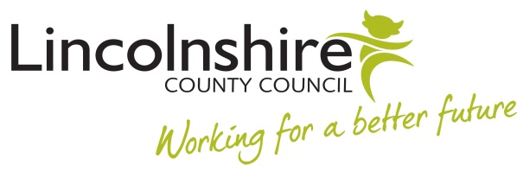

18th October 2022

For the attention of the Head Teacher
Safeguarding in Schools Self- Assessment Audit – Compliance for completion 2021/22
Dear Colleague,
The Safeguarding in Schools Self- Assessment Audit tool has been up and running since June 2016. Its main purpose is to help schools to monitor, evaluate and improve practice as well as encourage schools to gather relevant evidence to demonstrate good practice. It also provides the local authority with the assurance of safeguarding practice required for its maintained schools.
The completion of the audit is mandatory for maintained schools and therefore I am writing to inform you of your compliance in completing the audit for 2021/22. To be compliant your school must have:
- Completed the audit version 3
- Uploaded the Safeguarding in Schools Self- Assurance Audit 2020/21 review form into section 7.6 of the audit
The review form provides the evidence that the audit has been reviewed for this year and presented to the governors.
For 2021/22, your school is compliant.

Jill Chandar-Nair
Inclusion and Attendance Manager

