
Swinderby All Saints Primary School
Finance Report – November 2022
Financial Plan for 22/23
Following the Committee meeting in October and the report issued to the FGB meeting we’re still waiting for answers from County with regards to the NI and Utilities price cap. No further update has been provided since school’s were told to make the increases.
I did send our MTFP to School’s Finance, as per their instructions, after our healthy budget went into a deficit following the adjustments but their advice wasn’t ground breaking:
“You will be aware from the news that the NI increase is due to be reversed in November and there will be an energy cap applied to schools – unfortunately we do not have the details of what this actually means for schools yet, however in the interim the school need to start to undertake scenario planning in order to decide how the school are going to address the deficit. This might mean a staffing re-structure of some sort. The scenarios will need to be shared with Governors and should include the pro’s and con’s of each scenario – curriculum and financial. If any kind of re-structure is required please speak to your HR advisor who will be able to advise of the process.”
School’s Finance issued a letter to school’s late October offering advice on how to review our MTFP – a copy is attached to this report – ZL still need to work through some of these but I’d say the majority have already been considered at the time of initial budget planning.
Image 1 below shows the plan in May and what was agreed by the Governors to submit to County. Image 2 shows where we were at the start of the academic year and Image 3 shows where we were at the time of the emergency committee meeting at the beginning of October. Since this meeting, Zoe and I have gone line and line and reduced areas where possible. Image 4 was the position at the beginning of term and Image 5 is the current position following further amendments.
Image 1 – Governor Approved
Carry forward at the end of 22/23
Carry forward at the end of 23/24

Image 2 – Start of Academic Year 2022/2023
Carry forward at the end of 22/23
Carry forward at the end of 23/24
Carry forward at the end of 24/25
Image 3 – Following amendments due to School’s Finance bulletin
Deficit at the end of 22/23
Deficit at the end of 23/24
Deficit at the end of 24/25
Image 4 – Position as of 02.11.22

Deficit at the end of 22/23
Deficit at the end of 23/24
Deficit at the end of 24/25

***The changes made do not allow for the changes to NI or the Energy Price Guarantee, we’re still waiting for clarification from School’s Finance on how we will benefit and how the changes are to be implemented into the plan.***
In addition to the above, following an annual EHCP review a parent isn’t happy and didn’t feel her child was getting the required hours on their plan due to other need in the classroom. They insisted on a review and wanted a breakdown so they could clearly see the exact amount of time allocated to their child. This came on the last day of term (21.10.22) and by Monday 31.10.22 (first day back) had contacted ZL to ask what had been decided. ZL and I sat down and worked out the TA hours and what we could do with the people we have in school and have come up with a plan – which the parents, teachers and TA’s are happy with – which has had minimal impact on our budget.
However, we have another child in C2 that requires additional support. Currently, we have a TA with them every morning but the afternoons have been a struggle and since returning from half term, behaviour has escalated which resulted in 2 parent complaints. The child was put onto a part-time timetable as a temporary solution and kept out of the classroom. Following discussions with County’s re-integration team, HS and the child’s parents a plan has been put into place to bring the child back full-time, but (and County are in agreement) any disruptive behaviour will result in exclusion. This new plan has resulted in 1:1 support all day 5 days per week and currently no additional funding is being received. HS to work on an EHCP application but in the meantime school will have to take the hit on the cost. Following the adjustments to the additional TA hours the plan now looks as follows:
Image 5 – Current MTFP position – as of 03.11.22

Deficit at the end of 22/23
Deficit at the end of 23/24
Deficit at the end of 24/25

Stat from BBC Look North this morning (07.11.22)
“60% of Lincolnshire schools will end up with a deficit at the end of this financial year due to energy costs and will need to look at reducing staff costs in order to recoup some of this loss”

Summary Page

Graphs
The following graphs have been taken from the MTFP Dashboard.
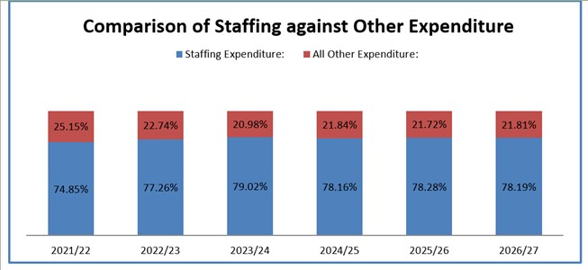
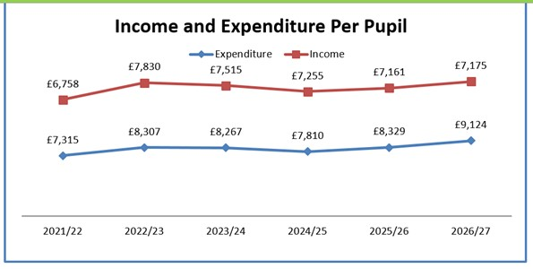

Pupil Numbers
We have received a mid-year application for a Y1 child which we accepted 03.11.22. However, because the census has been done for October we won’t receive any funding for this child until October 2023. We are also due to have 2 children join us w/c 07.11.22 (1 x Y6 and 1 x Y4). They were going to start first day back after half term but there was a delay with solicitors on the house sale. Unfortunately these children won’t be on the October 2022 census either.
We have had contact from a parent who applied for their child to start with us in September 2019 but they deployed to America with the RAF. They are returning to Lincoln in July 2023 and have requested places for both of their boys which we’ve confirmed we can take.
Teaching Staff
Please see above
Any pay increases for teachers have been built into the plan
Non-Teaching Staff
Please see above
Any pay increases for support staff have been built into the plan.
Grants
Grants have been utilised, where possible, to take the pressure off the main budget.
With the FSM grant, this can only be budgeted for on children already in school. If any more become eligible during the academic year, the plan will be updated. I have sent letters to all YR children suggesting that FSM applications are made. I know of 2 children, who I’ve approached directly, that are highly likely to be FSM but no applications as yet.
Devolved Capital
Confirmation that the lockers can be allocated and codes received. Journal created to move the cost of the lockers to Devolved Capital following confirmation that this cost could be moved.
The waste pipe into the boiler house has finally been repaired! We now have a fully functioned kitchen sink.
Condition Survey
Following on from the condition survey that was carried out a year ago, ZL and I held a meeting with Michael Rickard our LCC asset manager and went through the report thoroughly. The following points were clarified:
Condition Survey Review
- In general, it is only the D1 categorised condition elements over £10k that will make it onto the following financial years R&M capital maintenance programme.
- Any condition item under £10k is for the school to fund, with the D1 elements the priority.
- If an element is over £10k and is added to the R&M capital programme, the school have to make a 5% contribution towards the overall costs.

The 5% contribution we have agreed to pay is purely going to cover the cost of the new windows which are due to be installed into Class 1 during the October half term – the windows have now been replaced with some minor adjustments still to be made, but Class 1 are already feeling the benefits of a draft free classroom.

The porta cabin has scheduled for demolition summer 2023 during the holidays. SF has spent a long time moving the musical instruments, tidying cupboards in school to make room and has done a brilliant job of finding everything a place. The porta cabin is now not being used. Need to get a quote to have the services capped off – this will be a cost to the school.

Pre-school
LC had a lengthy conversation with Geraldine O’Neill at County before the half term break and she’s very keen to work with us to integrate Preschool into school. I have received an email from Property Strategy team asking me to send any quotes for building work to them so the costs can be reviewed and they will ensure we’re getting value for money. Getting a quote is another matter! I have chased the contractor that came out before the summer holidays and I’ve still had no response.

