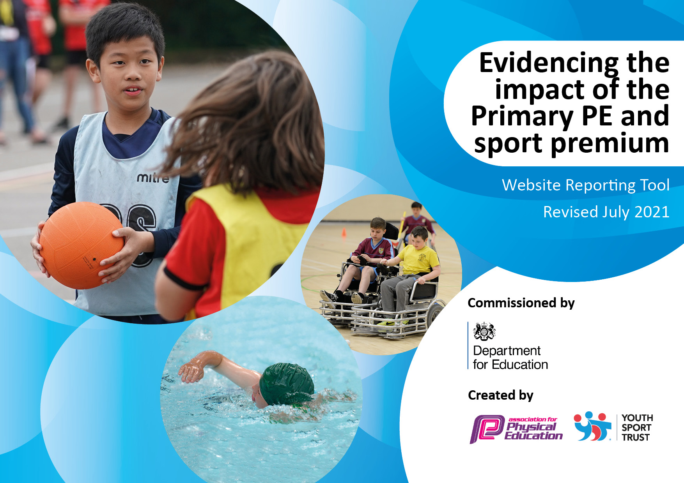
Revised July 2022
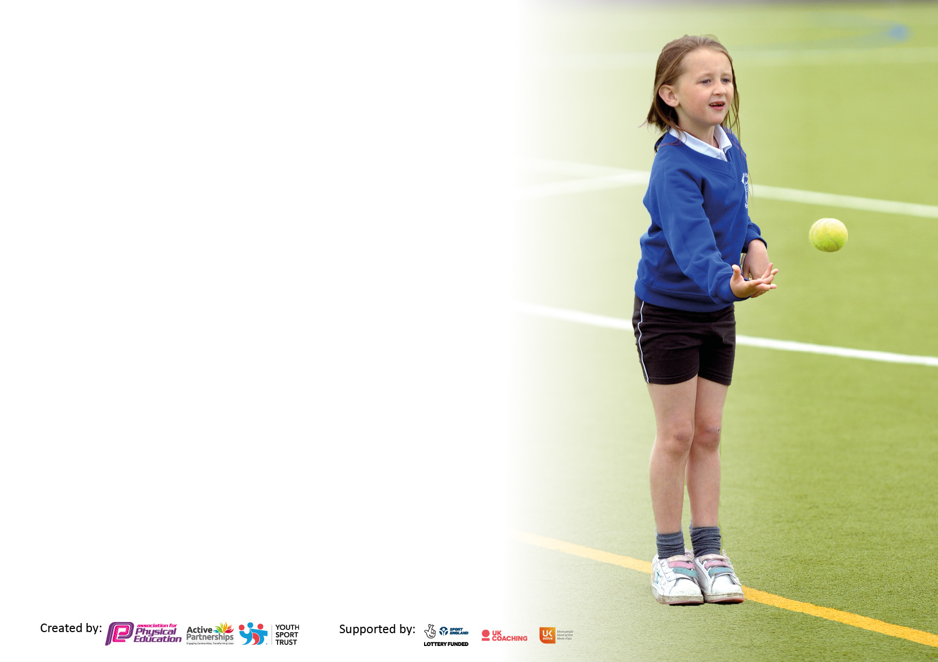

It is important that your grant is used effectively and based on school need. The Education Inspection Framework makes clear there will be a focus on ‘whether leaders and those responsible for governors all understand their respective roles and perform these in a way that enhances the effectiveness of the school’.

Under the Quality of Education Ofsted inspectors consider:
Intent - Curriculum design, coverage and appropriateness
Implementation - Curriculum delivery, Teaching (pedagogy) and Assessment
Impact - Attainment and progress

To assist schools with common transferable language this template has been developed to utilise the same three headings which should make your plans easily transferable between working documents.

Schools must use the funding to make additional and sustainable improvements to the quality of Physical Education, School Sport and Physical Activity (PESSPA) they offer. This means that you should use the Primary PE and sport premium to:

- Develop or add to the PESSPA activities that your school already offer
- Build capacity and capability within the school to ensure that improvements made now will benefit pupils joining the school in future years
- The Primary PE and sport premium should not be used to fund capital spend projects; the school’s budget should fund these.

Pleasevisitgov.ukfortherevisedDfEguidanceincludingthe5keyindicatorsacrosswhichschoolsshoulddemonstrate animprovement.Thisdocumentwillhelpyoutoreviewyourprovisionandtoreportyourspend.DfEencouragesschools to use this template as an effective way of meeting the reporting requirements of the Primary PE and sport premium.

We recommend you start by reflecting on the impact of current provision and reviewing the previous spend.

Schools are required to publish details of how they spend this funding, including any under-spend from 2021/2022, as well as on the impact it has on pupils’ PE and sport participation and attainment. All funding must be spent by 31st July 2022.

We recommend regularly updating the table and publishing it on your website throughout the year. This evidences your ongoing self-evaluation of how you are using the funding to secure maximum, sustainable impact. Final copy must be posted on your website by the end of the academic year and no later than the 31st July 2021. To see an example of how to complete the table please click HERE.


Created by: Supported by:

Details with regard to funding
Please complete the table below.

Total amount carried over from 2021/2022 | £-485
Total amount allocated for 2021/2022 | £16,688
How much (if any) do you intend to carry over from this total fund into 2022/2023 | £0 N/A
Total amount allocated for 2022/2023 | £16,668
Total amount of funding for 2022/2023 To be spent and reported on by 31st July 2023 | £16,184
Swimming Data
Please report on your Swimming Data below.

Meeting national curriculum requirements for swimming and water safety.  N.B. Complete this section to your best ability. For example you might have practised safe self-rescue techniques on dry land which you can then transfer to the pool when school swimming restarts.  Due to exceptional circumstances priority should be given to ensuring that pupils can perform safe self rescue even if they do not fully meet the first two requirements of the NC programme of study | All pupils have been taught techniques for all main strokes. They have been assessed on their ability to swim 25m on their front and back. They have also be taught how to tread water, jump into the deep end of the pool both aided and unaided and how to safely conduct water rescues.
What percentage of your current Year 6 cohort swim competently, confidently and proficiently over a distance of at least 25 metres?  N.B. Even though your pupils may swim in another year please report on their attainment on leaving primary school at the end of the summer term 2021.  Please see note above | 60%
What percentage of your current Year 6 cohort use a range of strokes effectively [for example, front crawl, backstroke and breaststroke]?  Please see note above | 60%
What percentage of your current Year 6 cohort perform safe self-rescue in different water-based situations? | 60%
Schools can choose to use the Primary PE and sport premium to provide additional provision for swimming but this must be for activity over and above the national curriculum requirements. Have you used it in this way? | No

Action Plan and Budget Tracking
Capture your intended annual spend against the 5 key indicators. Clarify the success criteria and evidence of impact that you intend to measure to evaluate for pupils today and for the future.

Academic Year: 2022/2023 | Total fund allocated: | Date Updated:
Key indicator 1: The engagement of all pupils in regular physical activity – Chief Medical Officers guidelines recommend that primary school pupils undertake at least 30 minutes of physical activity a day in school |  |  |  | Percentage of total allocation:
 |  |  |  | 90%
Intent | Implementation |  | Impact
Your school focus should be clear what you want the pupils to know and be able to do and about  what they need to learn and to  consolidate through practice: | Make sure your actions to achieve are linked to your intentions: | Funding allocated: | Evidence of impact: what do pupils now know and what can they now do? What has changed?: | Sustainability and suggested next steps:
Children are provided with an inclusive PE curriculum which allows pupils to develop their knowledge, skills and understanding of a range of sports. Alongside their development of both skills and knowledge, children will be taught the importance of having a healthy lifestyle and being active. | Ensuring that all children have an access to x2 1 hour PE lessons a week. 1 hour to be taught by an outside agency (Premier Education) and 1 hour by Class Teacher. | Staffing cost - £8352  Premier Education (Sep-March) - £4250 and £2080 (April-July) | Through scheduling pupil voice discussions throughout the year, the children are able to express their views and their understanding. Last academic year the children expressed which sports they would like adding to the PE curriculum. This was implemented at the start of the 2022 academic year. After carrying out observations each child is showing clear progression in both skills and knowledge. Children are also able to articulate the importance of being active and what it means to have a healthy lifestyle. | Continue to increase the amount of sporting activities which are provided during lunchtimes and after school.
Key indicator 2: The profile of PESSPA being raised across the school as a tool for whole school improvement |  |  |  | Percentage of total allocation:
 |  |  |  | 6%
Intent | Implementation |  | Impact
Your school focus should be clear what you want the pupils to know and be able to do and about  what they need to learn and to  consolidate through practice: | Make sure your actions to achieve are linked to your intentions: | Funding allocated: | Evidence of impact: what do pupils now know and what can they now do? What has changed?: | Sustainability and suggested next steps:
All children to be provided with increased opportunities to be active throughout the day. | - Swimming provided for all KS2 year groups.  - Sporting equipment regularly updated.  - Play and lunchtime equipment also updated and discussions held with pupils regarding what equipment they would like during these times. | PE mats - £789  Equipment - £317 |  | Continue to monitor equipment.

Key indicator 3: Increased confidence, knowledge and skills of all staff in teaching PE and sport |  |  |  | Percentage of total allocation:
 |  |  |  | 0%
Intent | Implementation |  | Impact
Your school focus should be clear | Make sure your actions to | Funding | Evidence of impact: what do | Sustainability and suggested
what you want the pupils to know | achieve are linked to your | allocated: | pupils now know and what | next steps:
and be able to do and about | intentions: |  | can they now do? What has
what they need to learn and to |  |  | changed?:
consolidate through practice:
All staff to mirror positive and enthusiastic attitudes towards PE.  All staff able to inform the PE lead how their children are progressing and in which areas. | - Regular observations  - Training on the PE portal for new staff.  - Regular assessments in PE.  - Termly assessments reported to PE lead. | Portal paid from last year’s Sports Premium. | All staff have secure understanding of the progression of their children and have adapted lessons where necessary. Consistent assessments carried out throughout the school. | Staff questionnaire to be sent out again and staff to attend coaching courses where necessary.
Key indicator 4: Broader experience of a range of sports and activities offered to all pupils.  Key indicator 5: Increased participation in competitive sport. |  |  |  | Percentage of total allocation:
 |  |  |  | 13%
Intent | Implementation |  | Impact
Your school focus should be clear | Make sure your actions to | Funding | Evidence of impact: what do | Sustainability and suggested
what you want the pupils to know | achieve are linked to your | allocated: | pupils now know and what | next steps:
and be able to do and about | intentions: |  | can they now do? What has
what they need to learn and to |  |  | changed?:
consolidate through practice:
Additional achievements:  2021-2022 – Achieved Gold in the School Games Award | - Participation in sporting activities outside of the school grounds.  - Balanceability and Archery slots allocated each academic year. | Archery - £525  Balanceability - £350  Bus Hire - £1272 | Children provided with sporting opportunities which may not have arisen outside of school.  Children becoming more confident when competing against different groups of children. | Continue to contact local schools for sporting competitions e.g. Netball and Football matches or Multi-skills events.
Signed off by
Head Teacher:
Date:
Subject Leader:
Date:
Governor:
Date:

