
Swinderby All Saints Primary School
Governor Finance Report – February 2023
Financial Plan for 22/23
Since our last meeting, I have been contacted by School’s Finance (on 05.12.22) asking for a copy of our MFTP as we had triggered the Monitoring and Intervention Policy again. I questioned whether this was correct as we submitted a favourable budget back in May 2022 and was it because of the adjustments we’d made (we’ve had no correspondence other than this email) and all that came back was they needed to see our MTFP. I sent both the May 2022 Governor approved version and our latest version – so they had a comparison – and I’ve heard nothing since! I have chased up asking for some feedback but no response.
From returning from the Christmas break, we have had to make numerous changes to the plan again due to some significant changes (and some potentials) within school
- Resignation of one teacher
- Secondment of another staff member from TA to Teacher (this effected multiple roles)
- Temporary class TA (FT) to replace seconded member of staff
- Additional TA support (PT) required as a 1:1 – EHCP paperwork in progress but no funding currently being received. Needs of the child need to be met in the meantime
- Changes to caretaking staff due to secondment of another staff member
- Increase in pupil numbers – 2 new children have started with us and are on role, another 3 due to start in February
Image 1 below shows the plan in May and what was agreed by the Governors to submit to County. Image 2 shows the plan following the amendments (pay rises, NI, energy costs etc.) highlighted in the School’s Finance bulletin and Image 3 is where we were at currently.
Image 1 – Governor Approved
Carry forward at the end of 22/23
Carry forward at the end of 23/24

Image 2 – Following amendments due to School’s Finance bulletin
Deficit at the end of 22/23
Deficit at the end of 23/24
Deficit at the end of 24/25
Image 3 – Position as of 01.02.23

Deficit at the end of 22/23
Deficit at the end of 23/24
Deficit at the end of 24/25

There may still be more adjustments to be made before the financial year is complete.

Summary Page

Graphs
The following graphs have been taken from the MTFP Dashboard.
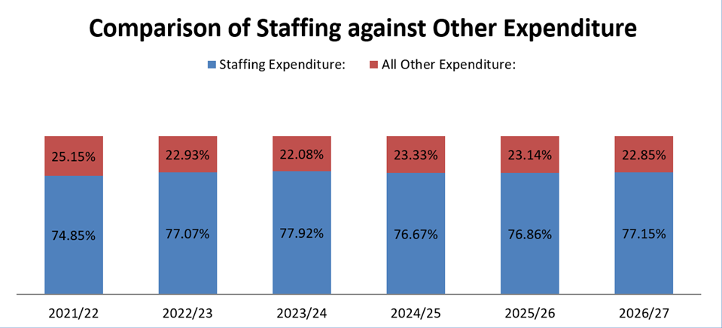
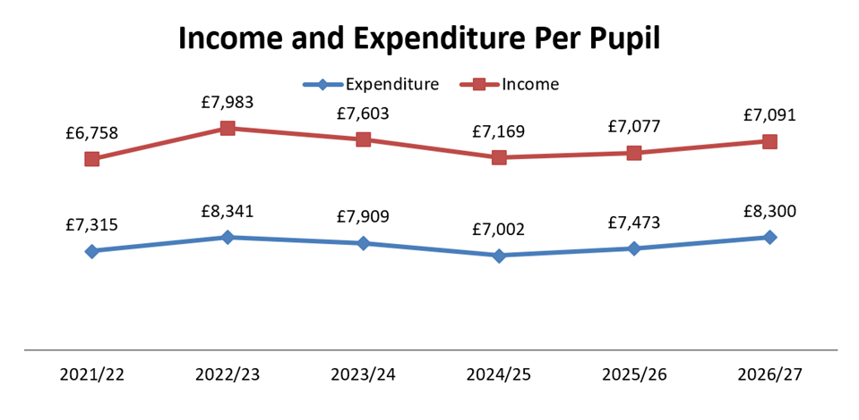
Pupil Numbers
As mentioned above, 5 mid-year admissions have been accepted.
- 2 x Y1
- 1 x Y2
- 1 x Y3
- 1 x Y5
Only 2 of these children are currently on role and are in school. Another 2 are waiting for their visas to be returned but should be with us in February and the final child was due to start with us in January but the exchange on their new house in WSH is still waiting to go through. No definite date confirmed for this final admission. We will not see any funding for these children until after the October 2023 census – so long as they continue to remain on our role. All of them applied to WSH first but the year groups were full.
Initial applications for September showed 12 first choices. This then changed to 11 as one application was removed. On checking the application system again, this has now risen to 13 as the Notts CC applications showing. We can see a list of children but we cannot see who has picked us as first choice. We have a list in school on who we’ve showed around and siblings etc. so can make an educated guess. We already know that one of the first choices are in the process of having an EHCP applied for through their nursery which will continue through school and they will require a 1:1. This is something ZL and I will be mindful of when setting the 23/24 budget.
Teaching Staff
Please see above
Any pay increases for teachers have been built into the plan
Non-Teaching Staff
Please see above
Any pay increases for support staff have been built into the plan.
Grants
Grants have been utilised, where possible, to take the pressure off the main budget.
With the FSM grant, this can only be budgeted for on children already in school. If any more become eligible during the academic year, the plan will be updated. I have sent letters to all YR children suggesting that FSM applications are made. I know of 2 children, who I’ve approached directly, that are highly likely to be FSM but no applications as yet.
Devolved Capital

Condition Survey Review
The porta cabin has scheduled for demolition summer 2023 during the holidays. SF has spent a long time moving the musical instruments, tidying cupboards in school to make room and has done a brilliant job of finding everything a place. The porta cabin is now not being used. Services have now been capped off.

VAT and Climate

I attended a couple of SBM meetings in January and something that came up was the Climate Change Levy (CCL) charges that can be added to energy bills. If a school has exempt charitable status then this charge should be applied to bills. Exempt charitable status applies to Voluntary Aided, Voluntary Controlled and Foundation schools (also to Academies), the governors being the trustees (Advice template (publishing.service.gov.uk)). Due to their charitable status, these schools qualify for 5% VAT (& no CCL charge). It appears that some are being charged VAT at 20% + CCL. The VAT is not an issue since it is fully recoverable, however the CCL charges are an additional cost to the school.

I need to check our energy bills to see if this is something we’re being charged, if we are there is a form that can be completed to stop this from happening. To investigate further.

Outdoor Play Equipment

Our annual Sports Safe inspection took place on 23.01.23 and unfortunately, all the remaining wooden equipment and the soft surfacing has been condemned. The surface no longer complies with H&S guidelines due to the holes – where equipment has been removed in the past – and it is deteriorating. The wooden items are rotten and no longer fit or safe for purpose. ZL is keen to have this area rejuvenated as soon as possible and has a meeting planned with FOSS on Friday 03.02.23 (AM) to move things forward. We need to have all the old equipment removed and the area reseeded and we need to choose a contractor and have the new trim trail installed as soon as possible.

Initial quote from SELMEC to dismantle all wooden equipment, rip up the soft surfacing, level and make good for reseeding and remove all debris from site is £3,588.

I have reported this to Matt Whitehead at LCC (he carried out our Conditions Survey and the outdoor area was listed as a cat. C. I’ve advised it’s been condemned and he’s agreed to update the survey to D. He advised that he didn’t think County would offer any monetary assistance with the area due to it being the school’s choice to have it installed – it’s not a necessity.

