
Swinderby All Saints Primary School
Governor Finance Report – May 2023
Financial Plan for 22/23
Planning the 23/24 budget has been somewhat challenging and there have been multiple finance committee meetings to assist with the decision making. Some hard decisions have had to be made and we have done our best to prevent any staff losses but even with all the changes and sacrifices we’re still showing a deficit budget across the 5 years.
We ended 22/23 with a very small carry forward (-£3,981), which was a better position than we thought because in February we were showing a predicted deficit of £8,458. However, this carry forward isn’t enough to help with the 23/24 budget. ZL and the Finance Committee have composed a letter to County ahead of submitting this deficit budget to highlight our position.
Image 1 below shows the plan we’re submitting for approval.
Image 1 – For Governor Approval
Deficit at the end of 23/24
Deficit at the end of 24/25
To put into context what has been included;
- Teaching staff
  - We have removed an UPS teacher who left us at February half term
  - An M1 teacher took over on return from Feb half term until 31.08.23
  - We have recruited a new M3 teacher for Y3/Y4 from September
  - EYFS teacher for YR from September remains as M1
  - SENCO – currently on long term sick but have budgeted for the full year and beyond.
- Support Staff
  - We have recruited a temporary 1:1 TA for a child in Y1. This is part-time as it’s all the budget could afford. This child is currently in the process of having an EHCP written
  - We have a temporary full-time classroom assistant in C1 following the successful secondment of CH to class teacher. This post ends 31.08.23. Amongst the new YR children, there are 2 children who are having EHCP's written (one of which has just been granted). Once we know how many hours this full-time TA may be redeployed as a 1:1 but potentially on reduced hours.
  - We have had to re-deploy TA’s to only work as 1:1 support from September onwards. There will be NO general class TA’s from September
- Pupil Numbers
  - These have increased considerably, taking us to 90 in September. We have 14 first choice pupils starting in Reception in September
  - Mid-year admissions – we know of a RAF family returning to the Swinderby area in the summer and have been in contact asking for places in Y1 and Y3 for September. The family had originally put us down as first choice when their eldest was due to start Reception but then got posted to the States. Once they have an address confirmed they will be submitting their mid-year application to us.
  - Another family have moved to the village and are looking around the school on Friday 26th May with the potential of moving their children from Muskham Primary.
  - Another family are visiting school on Wednesday 17th May as they have moved to Witham from abroad and have already applied to Swinderby as a mid-year admission. We have confirmed to County that we have space in YR for this child but we don’t know if we were 1st, 2nd or even 3rd on their application. We know they are visiting Bassingham also on Wednesday.
  - We have the potential to have 95 children on roll come September.
  - This increase in pupil numbers doesn’t have an effect on the budget until 24/25 as it is taken from the previous census data. Therefore 23/24 is based on October 2022 data (a total of 79 pupils). If we did have 95 children in September to deficit for 24/25 would decrease considerably
Deficit at the end of 23/24
Deficit at the end of 24/25
- Class Structure
  - In order to meet the needs of the school we have had to maintain the 4 classes. They will be as follows:
    - Class 1 – Reception (14 + 1 x Y1)
    - Class 2 – Y1 and Y2 (24)
    - Class 3 – Y3 and Y4 (23)
    - Class 4 – Y5 and Y6 (28)
  - This structure has been agreed with the locality lead as she has agreed, there is no other alternative based on our numbers. This structure also allows for some mid-year admissions.
- EHCP’s
  - EHCP children have had a significant impact on our budget. As a school of less than 100 pupils we should have 1 EHCP. We currently have 5 with another 1 in process and 2 of the new Reception children are having EHCP’s written and should be in place when they start with us.
  - A separate piece of work has been done to send to County to show this impact on an already tight budget. With us having 5 EHCP’s we’ll have a shortfall of £36k on our budget once all funding has been received.
  - We have also shown to County that we’ve spent £12k providing 1:1 support for a child whilst their EHCP was being processed.

- Expenditure
  - We have reduced the supply costs by ZL covering ECT time and any sickness for the teachers, subject lead days for the Teachers have been reduced and there is no longer a report writing day
  - We have cut back on training and resources where at all possible
  - We have split coded any costs to grants where possible
  - We have lost the outdoor learning with A Little Bit Wilder as the budget couldn’t stretch to this.
Summary Page
Graphs
The following graphs have been taken from the MTFP Dashboard.
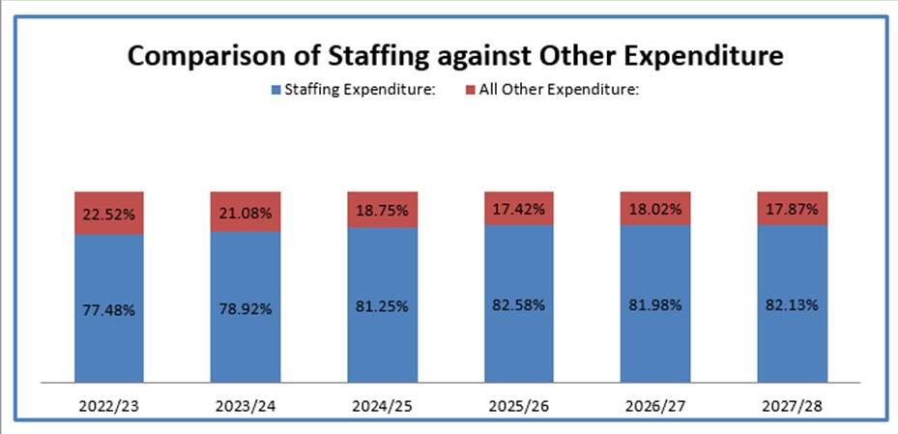
We appreciate that our staffing costs are high but we’re unable to cut any further based on 4 teachers and TA’s are 1:1 support only.
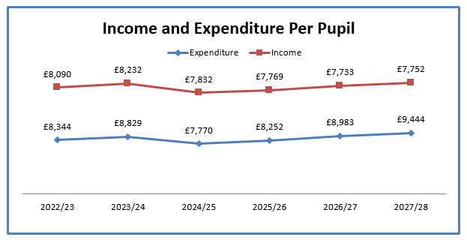

Pupil Numbers
Teaching Staff
Please see above
Any pay increases for teachers have been built into the plan
Non-Teaching Staff
Please see above
Any pay increases for support staff have been built into the plan.
Grants
Grants have been utilised, where possible, to take the pressure off the main budget. There is still scope to allocate a little more to the grants.
Devolved Capital
The table below shows our Devolved Capital allocation for 23/24. We have already requested quotes for a new whiteboard for Class 3 – this is the last class to have a new board installed.
Following on from our latest fire door inspection, all our doors (bar 1) failed the inspection as they no longer meet current standards (these were changed following the Grenfell disaster). The majority of work required is on hinges and gaps. The initial quote from Selmec is coming in at approximately £3,800 which we’re hoping can be covered from Devolved.
Condition Survey Review
The porta cabin has been scheduled for demolition during the May half term (this has been brought forward from the summer). SF has spent a long time moving the musical instruments, tidying cupboards in school to make room and has done a brilliant job of finding everything a place. The porta cabin is now not being used. Services have now been capped off. The company undertaking the demolition are in school on Thursday 18th May to ensure electrics are disconnected and a pre-start meeting is scheduled for w/c 22.05.23.

Outdoor Play Equipment

Pleased to report following the generosity of parents with their time and resources, all the condemned play equipment has been dismantled and removed from site and we have a new grass area with wigwams a train, a buddy bench, new goal and fencing. This, alongside the fabulous fundraising effort from FOSS and the new trim trail that was installed at the end of March, the outdoor area is looking wonderful.

