
Swinderby All Saints Primary School
Governor Finance Report – July 2023
Financial Plan for 22/23
Following the Governor meeting back in May, the MTFP was submitted to County with a large deficit – see Image 1. Along with the plan, I also sent the accompanying letter that had been drafted by ZL and the Finance Committee and a copy of the SEN spreadsheet I had worked on, showing what the impact EHCP children were having on our budget (expenditure outweighing the income we receive as a school).
We received the standard response back advising us to ensure we are fully utilising our grants and that a high level check would be carried out over the summer break and the MTFP’s will then be uploaded to BW Hoople. Until the 23/24 plans are uploaded I am unable to carry out any Forecasts. With the new system going live in April, there are no finance reports that are available either. We were told they would have been added to the system in June, but still no luck.
We are also to expect a letter over the summer advising we have triggered the Monitoring and Intervention policy which will mean our plan will be regularly checked by the School’s Finance Team. We have been under this policy before and other than me sending the MTFP to School’s Finance a couple of times per year, there was no other feedback. We shall see!
There is some good financial news though, since approving the plan there have been some further changes to Teaching staff following resignations and confirmation of EHCP funding coming through for a child starting in YR. Image 2 below shows our current financial overspend position, which is considerably better than when the plan was approved.
Image 1 – Governor Approved
Deficit at the end of 23/24
Deficit at the end of 24/25

Image 2 – Current position (as of 06.07.23)
Deficit at the end of 23/24
Deficit at the end of 24/25
To put into context what has been included;
- Teaching staff
  - We have removed an UPS teacher who left us at February half term
  - We have removed an UPS teacher who will be leaving on 21.07.23
  - We have removed a P/T teacher (who would have gone to M4 in Sept) who will be leaving on 21.07.23
  - An M1 teacher currently on secondment has been taken on permanently for EYFS (YR) class.
  - We have recruited a new M2 teacher for Y1/Y2 from September
  - We have recruited a new M3 teacher for Y3/Y4 from September
  - SENCO – unfortunately has had to resign due to ill health but we have recruited a new SENCO from September – who is proving very valuable already and working well with ZL – who will work 1 full day per work at UPS3
  - We have also budgeted for current M6 teacher to have a pay increase to UPS from September.
- Support Staff
  - We have recruited a temporary 1:1 TA for a child in Y1. This is part-time as it’s all the budget could afford. This child is currently in the process of having an EHCP written. This TA’s contract has been extended until December 2023. The new SENCO will continue working on the EHCP.
  - The F/T TA in C1 will be staying on in September but will be moving to a 1:1 role following an EHCP that has been granted for a pupil starting in September. Their hours have been reduced from 32.5 to 25.
  - We have had to re-deploy TA’s to only work as 1:1 support from September onwards.
  - We have managed to keep 1 TA as general – in order for us to have enough cover for Phonics. However, their hours have been reduced from 21 to 10.5.
  - No other support member of staff has lost hours.
- Pupil Numbers
  - These have increased considerably. We are currently showing 91 in September. We have 13 first choice pupils starting in Reception in September (we did lose one)
  - Mid-year admissions – the RAF family moving from America have applied and their places confirmed for Y1 and Y3 in September.
  - The family that visited with children at Muskham Primary have made an application for Y2 and Y4 in September – these have been accepted.
  - We recently accepted an application for a boy joining Y4 in September whose family are moving to the village.
  - If all our current children on role and the new mid-year’s stayed we’d have the potential to have 94 children on role. However, we are aware that 2 of the children who joined us from Nigeria in February are moving so won’t be returning to us in September. There is also the potential of another 2 children also moving but their parents have said they haven’t found a house yet.
  - One of the YR children who has been granted a place is currently going through an EHCP and has significant need. On advice from our new SENCO we have decided to reject the application based on such a high need in the EYFS class already and across the school as a whole. It could be that we still get this child, it’s just a waiting game now but this could reduce our numbers further.
If we lose all 5 of these children, the budget will look as follows:
Image 3 – Loss of Children on Role
Deficit at the end of 23/24
Deficit at the end of 24/25
- Class Structure
  - In order to meet the needs of the school we have had to maintain the 4 classes. They will be as follows:
    - Class 1 – Reception (12 + 1 x Y1)
    - Class 2 – Y1 and Y2 (26)
    - Class 3 – Y3 and Y4 (25)
    - Class 4 – Y5 and Y6 (27)
  - This structure has been agreed with the locality lead as she has agreed, there is no other alternative based on our numbers. This structure also allows for some mid-year admissions.

Summary Page

Graphs
The following graphs have been taken from the MTFP Dashboard.
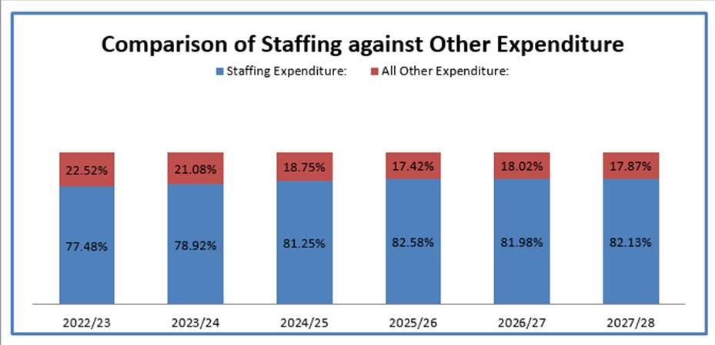
We appreciate that our staffing costs are high but we’re unable to cut any further based on 4 teachers and TA’s are 1:1 support only.
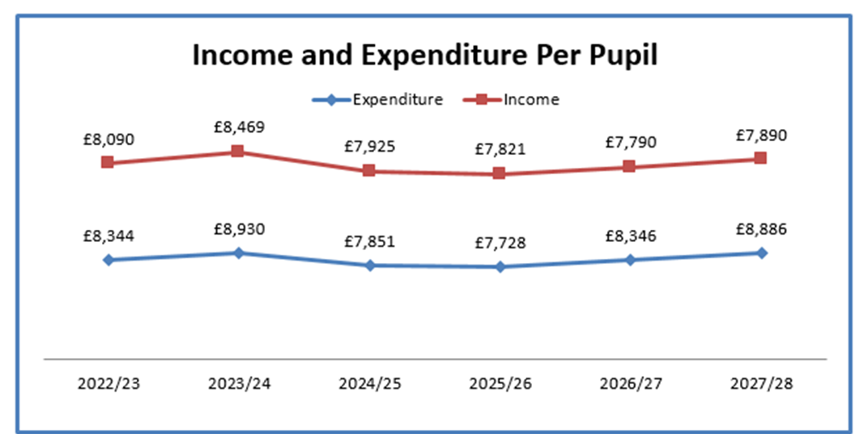

Pupil Numbers
Teaching Staff
Please see above
Any pay increases for teachers have been built into the plan
Non-Teaching Staff
Please see above
Any pay increases for support staff have been built into the plan.
Grants
Grants have been utilised, where possible, to take the pressure off the main budget. There is still scope to allocate a little more to the grants.
Devolved Capital
The table below shows our Devolved Capital allocation for 23/24.
The new whiteboard for class 3 is due to be installed before the end of term.
Following on from our latest fire door inspection, all our doors (bar 1) failed the inspection as they no longer meet current standards (these were changed following the Grenfell disaster). The majority of work required is on hinges and gaps. The initial quote from Selmec is coming in at approximately £3,800 which we have had confirmation can be covered from Devolved. The work has been booked in and will be completed in August.
We do need to upgrade our phone system so it is cloud based as in the next couple of years, all analogue phone lines will be switched off. We’ve had one quote from Gateway – our current supplier and the company that installed our existing phone lines and this is coming in at £2,116. This may be something we can pay for from Devolved. ZL and TS to discuss further.
Condition Survey Review
The porta cabin has been removed.

FOSS

Following on from the very successful fundraising of our FOSS Team and the new outdoor equipment, they are now in the process of raising funds to upgrade our library.

