




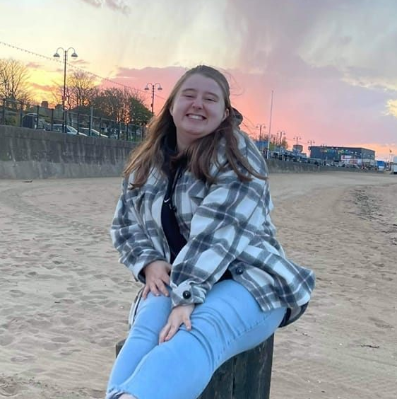


Colour: Pink
Film: Star Wars
Food: Sushi
Book: The Faraway Tree
Singer: Taylor Swift
Musical: Wicked
Flower: Peony
My favourites
Hello, my name is Miss Walker and I am going to be your new teacher!
This will be my first year teaching at Swinderby All Saints and I am looking forward to joining the school!
I was born in Lincoln and went to Bishop Grosseteste University to study.
I have had lots of experiences working with children aged 2-7 years old and use the skills that I have learned to ensure my teaching is fun, engaging and accessible to all.

My classroom will be an inviting and inclusive space for all and I look forward to working closely with parents/carers to ensure the best for all of my pupils.

