
Swinderby All Saints Primary School
Governor Finance Report – October 2023
Financial Plan for 22/23
As predicted, we have triggered the Monitoring and Intervention Policy for this financial year. The first step was to submit an up to date MTFP to County, with a deadline of 29.09.23. This was submitted on 27.09.23 and at the time of writing no reply or response has been received. The plan is in a better position from the one submitted in May 2023. I have also managed to submit our first forecast and check a Budget Report to check our percentage spend for the year and so far we’re on track with our expenditure (see attached spreadsheet).
Image 1 – Governor Approved
Deficit at the end of 23/24
Deficit at the end of 24/25
Image 2 – Current position (as of 28.09.23)
Deficit at the end of 23/24
Deficit at the end of 24/25
There have been some further adjustments to the plan, as advised by LCC. The Teacher’s pay increase has been amended from 5%-7.14% to 6.5%-7.14% (depending on pay grade) as this has now been agreed, holiday entitlement has increased so the plan has been updated to reflect this and we also had some TA overtime to cover additional 1:1 support in the last academic year. There should be minimal need for this going forward (only to cover absences) as all TA’s are now on a contract rather than relief.

Summary Page
Graphs
The following graphs have been taken from the MTFP Dashboard.
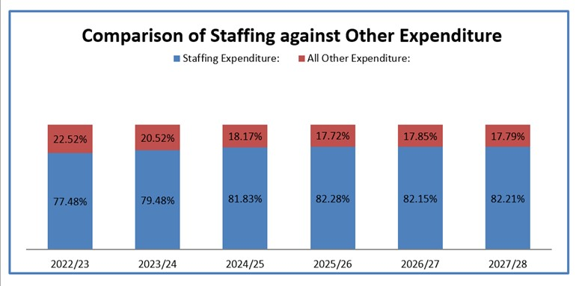
We appreciate that our staffing costs are high but we’re unable to cut any further based on 4 teachers and TA’s are 1:1 support only.
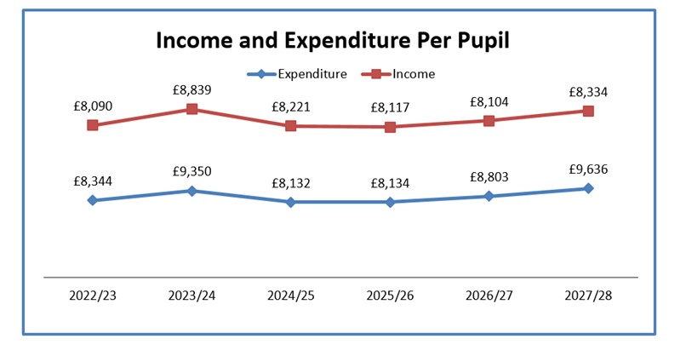

Pupil Numbers
We are really pleased to confirm that we have the highest number of pupils for a while – we’re currently 92 on role, after gaining a further 2 mid-year admissions early into the academic year. The Census is due on 05.10.23 and this will be our funding level for 2024/25.
Maintaining these numbers may be tricky going forward, especially with the added pressure of the Pre-school closure. We are currently promoting and marketing the school on all social media platforms, have had new photos taken of and around the school, which in turn will update our school website, and we’re having professional flyers made which should hopefully be ready w/c 02.10.23. ZL has dropped leaflets directly into Appletree nursery and will make a visit to the local toddler groups. Word of mouth is also vital. This all coincides with our planned Open Mornings throughout the year ahead of the January 2024 closing date for Reception applications.
Teaching Staff
Please see above
Any pay increases for teachers have been built into the plan
Non-Teaching Staff
Please see above
Any pay increases for support staff have been built into the plan.
Grants
Grants have been utilised, where possible, to take the pressure off the main budget. There is still scope to allocate a little more to the grants.
We have gained 2 further service children at the start of this academic year, ZL and TS to discuss further on what this funding should be used for.
Our LAC child has now become Post LAC – ZL and TS to work on updating this funding and determine what future funding we will be entitled to.
Devolved Capital
The table below shows our Devolved Capital allocation for 23/24.
The new whiteboard for class 3 has now been installed. That is all classrooms up to date with new whiteboard equipment.
SELMEC did a fantastic job of repairing and making good our fire doors. We were re-inspected at the start of term and the engineer reported what a good job had been done and we passed! Added bonus was that the work came in cheaper that the original quote (£2,475 instead of £3,800!!)
I have had confirmation that the telephone system can be purchased from Devolved and the go ahead was given to Gateway Technology to start with the upgrade. This was given on 28.09.23 and they’ve advised a 10-14 working day lead time. We will have new handsets – one of the features will allow us to divert phones to mobiles if ZL or TS are working from home. Parents can contact the school and speak to one of us if we’re not in the building.
Mrs Feast has advised that the hall wooden floor is becoming increasingly fragile and if we’re not careful we’ll need it replacing. It has lost the coating which means any liquid spilt is soaking into the wood and damaging it. SF has had one contractor in to quote for work to replace this coating (rather than a whole new floor) and this is coming in at £2,250. We’re waiting on another quote w/c 02.10.23 but we’re hoping this can be funded out of Devolved in order to give the hall a new lease of life.
Pre-school
The Pre-school have now officially closed and are in the process of getting the porta cabin removed. They only have 1 official trustee left and with the help of 2 parents they’re trying to sort the porta cabin removal but there are no funds to do this, they are insolvent. LCC are involved directly with the volunteers and assisting where they can. A meeting was held on 27.09.23 with LCC and the school (ZL, TS and LC present), as Pre-school had wanted to ‘gift’ the porta cabin to us but Corporate Property at LCC have refused to take on the maintenance costs and they feel we don’t need any additional space so it’s an absolute no from them. Preschool’s current deadline (in line with their lease) is January 2024 to have the porta cabin removed and the land made good but they’re pushing for an extension – Julie Grindley of LCC will re-look at this in October.

The land will be ‘returned’ to school for us to use once it has been vacated.

FOSS
FOSS are now looking at fundraising to update our library. ZL has been in contact with one company, which came recommended by another Head. SF to take measurements of the library so they can work on putting a quote together so we have an idea on what funds need to be raised. We’re hoping to create an immersive, usable, space where children can enjoy their reading and feel inspired.

