
Swinderby All Saints Primary School
Governor Finance Report – November 2023
Financial Plan for 22/23
Our MTFP was submitted to County in line with their Monitoring and Intervention Policy on 27.09.23. There has been no further feedback or requests following this submission.
Image 1 – Governor Approved
Deficit at the end of 23/24
Deficit at the end of 24/25
Image 2 – Current position (as of 13.11.23)
Deficit at the end of 23/24
Deficit at the end of 24/25
National Funding Formula
On 09 November 2023, Schools Finance contacted schools to advise that that DfE had been in touch at the end of October advising they had identified an error during their initial calculations of the NFF for 24/25, specifically there was an error in forecasting pupil numbers, which meant the overall cost of Core Schools Budgets would be 0.62% greater than funding available. The error has resulted in a reduction in the NFF factor values for 24/25. All formula factors (except for FSM) have reduced by 1%. This means that the funding incorporated into the MTFP for 24/25 onwards has been overstated. Following School’s Finance guidance 1% has been deducted from our funding (just over £5,000/an) and the MTFP updated with this reduction.

Summary Page
Graphs
The following graphs have been taken from the MTFP Dashboard.
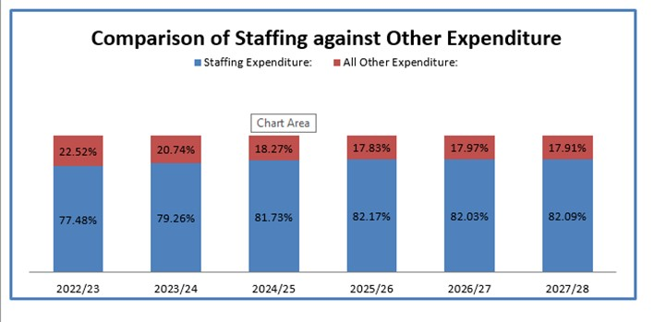
We appreciate that our staffing costs are high but we’re unable to cut any further based on 4 teachers and TA’s are 1:1 support only.
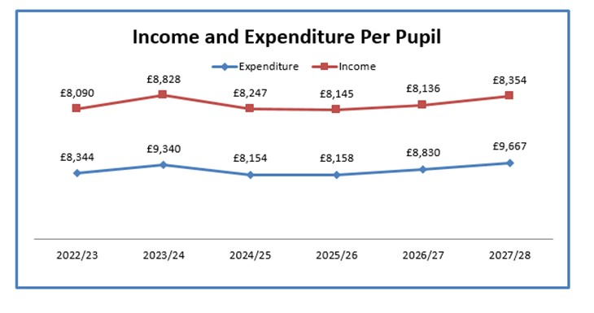
Unforeseen Costs
A neighbour reported that one of our big trees in the woodland area is overhanging his garden and koi carp pond and he wants us to get it cut down as he’s worried about the amount of storms and the lean of the branch. We have contacted 1 parent who’s a tree surgeon and he’s provided a quotation of around £800 but he wouldn’t be able to get his equipment into the neighbour’s garden to carry out the work. TS has also been in contact with LCC. Last time we had a tree survey carried out we were advised that any removal/pruning costs the school were liable for, I have asked the question what happens now seeing as our budget is in significant deficit and the email has been directed to Corporate Property at LCC. Contact was made on 11.10.23 and my query passed to Corporate Property on the same day, but no response as yet. I have chased for an answer. The neighbour is in contact with TS and SF via email and is asking for an update. TS has also contacted B&B Tree Specialists to come out and provide a quote but no further response other than ‘someone will be in touch to arrange a convenient time’.

Additional Income
To try and generate some income for the school to alleviate the deficit budget, ZL is investigating Swinderby becoming an HAF provider. The HAF programme is a Government funded programme that provides reception to year 11 pupils, who receive benefits-related free school meals in Lincolnshire, access to free healthy meals and activities over the summer, Christmas and Easter holidays. There are over 100 clubs being delivered across the county during the Christmas holidays. The mapping tool on the HAF Webpage highlights the HAF provision being delivered across the county. We would ‘hire out’ the school’s space during the holidays to generate some income. ZL has a meeting booked with the HAF team.
We could also look at potentially hiring out the hall for dance lessons etc. and possibly the MUGA.
Pupil Numbers
The Census is completed on 05.10.23 and 92 children were on role that day (and remain on role) this will be our funding level for 2024/25.
Following the professional photos that were taken, our school website has now been updated with current photos of staff and children. We have been actively promoting the school in the local area with flyer drops in the local businesses and nurseries. We have stayed clear of promoting in Thorpe, Eagle and North Scarle due to working closely with these schools and ZL thought it may upset relations. We are also hoping to invite Appletree nursery and the local toddler group, held in Swinderby Village Hall, to the dress rehearsal of our Class 1 and 2 Nativity in December.
Pupil numbers for September 2024 is a significant worry for us as we only have 1 sibling who is due to start school. This was raised in our Finance Committee meeting and a will form part of the Strategy meeting scheduled for 21.11.23. ZL has also been in contact with Katherine Gilliat from Early Years and Child support in order to discuss the possibility of opening up to 3 year olds. TS to contact Matt Clayton at LCC to determine the projected future numbers.
Teaching Staff
Any pay increases for teachers have been built into the plan

Non-Teaching Staff
Any pay increases for support staff have been built into the plan.
Grants
Grants have been utilised, where possible, to take the pressure off the main budget. There is still scope to allocate a little more to the grants.
We have gained 2 further service children at the start of this academic year, ZL and TS to discuss further on what this funding should be used for.
Our LAC child has now become Post LAC – ZL and TS to work on updating this funding and determine what future funding we will be entitled to. We also have 1 child in Reception as PLAC. Both of these children are on our October Census and any funding they accrue will be received in 24/25 although spending should commence right away.
Devolved Capital
The new phone lines and handsets have been installed and now we’re waiting for the ports to change over (meaning we keep the same numbers) and this should take 2 weeks.
Mrs Feast has advised that the hall wooden floor is becoming increasingly fragile and if we’re not careful we’ll need it replacing. It has lost the coating which means any liquid spilt is soaking into the wood and damaging it. SF has had one contractor in to quote for work to replace this coating (rather than a whole new floor) and this is coming in at £2,250. We’re waiting on another quote w/c 02.10.23 but we’re hoping this can be funded out of Devolved in order to give the hall a new lease of life. The second quote still hasn’t come in. SF has chased Lincs Flooring but not getting a response. A further company – Farcroft – was contacted following some literature received in the post. SF arranged a meeting but they never showed! SF looking to get one more quote before proceeding.
FOSS
FOSS are now looking at fundraising to update our library. ZL has been in contact with one company, which came recommended by another Head. SF to take measurements of the library so they can work on putting a quote together so we have an idea on what funds need to be raised. We’re hoping to create an immersive, usable, space where children can enjoy their reading and feel inspired. No further action has been taken with this project as yet but it is still something we’re looking at starting/fundraising for. The last INSET day saw staff have a full clear out of the library and ICT suite partly in preparation for this.

