
Swinderby All Saints Primary School
Governor Finance Report – February 2024
SFVS (School’s Financial Value Standard)
The deadline for submission was 31.01.24. As this was before this Governor meeting, an extension was granted but a draft version needed to be submitted to LCC by the 31st. This was done and IL has the draft version ready for approval at tonight’s meeting.
Financial Plan for 22/23
Our MTFP was submitted to County in line with their Monitoring and Intervention Policy on 27.09.23. TS received an email on 09.01.24 from School’s Finance asking for some amendments to be made following their high level check. They asked for the following:
- Higher Needs funding for Child F – the total funding on the August 2023 Higher needs document is different to the amount on the MTFP, please adjust this.
- Please update teaching staff tabs with basic pay, NICs and pension for staff for October to December.
- Please also update teacher’s pay to account for back pay.
- Please update the non-teaching staff tabs with basic pay, NICs and pension and add overtime where applicable.
They requested that the changes were made and a new plan submitted by 11.01.24. TS took some time at home to complete and returned the revised plan, on 10.01.24, with the following comments:

I have had a look at the MTFP and as far as I can see the pay increases for Teachers have been included.

I applied the Teacher increase via the percentages at the top of the page (Tab 4a), as instructed, and applied them from September 2023. Obviously these weren't paid until this month but as far as the plan is concerned, the increase is WEF from 01.09.23. I have checked my plan against the Gross reports and the payments are correct. Would you agree? Because I made the increase effective from September, this would account for the back pay, would it not?

Non-teaching staff I had applied the increase but this was before the guidance had been sent in November. I have now updated the percentages on Tab 9 after changing the figures in tab 5b to values rather than formulas. I have now removed my previous figures from row 552 in the M2 section; columns BF552 (basic), BU552 (NI), DI 552 (Pension) and DJ552 (Total). Is this now correct?

I have Non-Teaching overtime showing in Tab 5a BT257. Is there somewhere else it needs to show?

I have checked the Higher Needs document and updated Child F accordingly. Child G also needed amending as didn't match the August 2023 document.

If I have mis-understood what you've asked of me, please let me know.

There was no further response to my email or the revised plan until Monday 29 Jan when School’s Finance contacted me asking where the plan was and I hadn’t done what they had asked. I confirmed the time and date the plan was resubmitted and School’s Finance confirmed they had it, just missed the email. Apologised and hung up!
Following these amendments, the School’s Finance team met on 16.01.24 to discuss further. The change to the Higher Needs funding, had a huge impact on our budget. Because Child F & G didn’t start with us until September their entitlement was pro-rata for this year.
Image 1 – Governor Approved
Deficit at the end of 23/24
Deficit at the end of 24/25
Image 2 – Position as of 13.11.23
Deficit at the end of 23/24
Deficit at the end of 24/25
Image 3 – Current Position (as of 01.02.24)
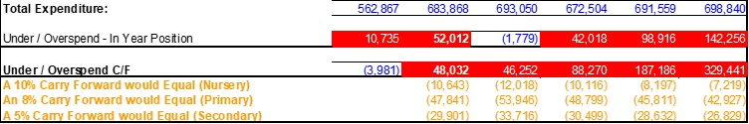
Deficit at the end of 23/24
Deficit at the end of 24/25
The Finance team also discussed the extremely low in take for September – we are currently only showing 1 first choice application. Applications in general are very low this year with only 15 applications made altogether (4 seconds and 10 thirds). We are still waiting for any Notts. applications to come through. TS has been in contact with Matt Clayton at County who confirms, there is no indication that primary intake numbers will rise any time soon, with birth rates remaining low. In an ideal world we’d like to keep the 4 classes in September in order to continue to deliver the curriculum effectively and look attractive to new parents. If we had to go back to 3 classes in September, this could potentially mean a R/1/2 class (due to pupil numbers) and any children currently in Y1 would come back down to Class 1. This wouldn’t be favourable with our parents.
The Finance team thought it would be beneficial to arrange a meeting with Elizabeth Bowes (School’s Finance Strategic Finance Manager) to discuss our situation further and to see if they could offer any advice. This meeting was arranged for Wednesday 31 Jan via Teams. However, Elizabeth cancelled on the morning due to a poorly child. We are currently trying to re-arrange for w/c 05.02.24.
We know from previous comments from School’s Finance and benchmarking that our staffing costs are high – our Support Staff is similar to our Teaching costs – but all or TA’s are 1:1 support, we have no general classroom assistants. The only other TA is employed on a part time basis to cover intervention. If we lost this staff member then intervention work wouldn’t get done and potentially our data would drop. They are a valuable member of our team.
On a positive to note, Child H had their EHCP application submitted before we broke up for Christmas and it looks as this has now gone to assessment (which means it hasn’t been rejected). If this EHCP is granted, we will receive some additional funding, which will help cover some of the cost of the 1:1 we have employed since May 2023 (but it won’t be backdated).
Summary Page
Graphs
The following graphs have been taken from the MTFP Dashboard.
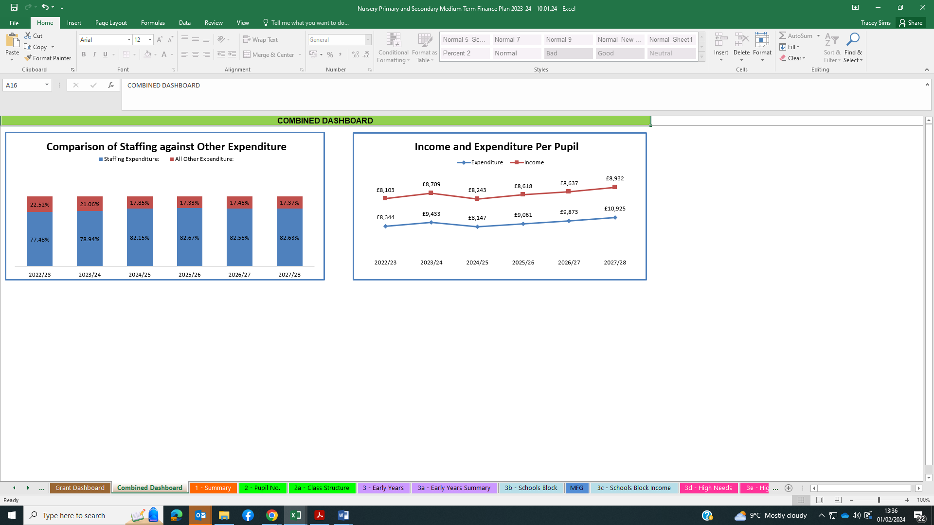
Pupil Numbers
The Census is completed on 05.10.23 and 92 children were on role that day (and remain on role) this will be our funding level for 2024/25.
ZL has discussed the possibility of providing a Nursery class with our Locality Lead – Michelle Wardell – and she didn’t think it would be a great idea. The costs involved to set up and staff wouldn’t be covered by the income. She advised there a lot of nurseries closing their doors because the income/funding doesn’t cover their expenditure. MW thinks it’s a project we don’t need.
Teaching Staff
Any pay increases for teachers have been built into the plan
Non-Teaching Staff
Any pay increases for support staff have been built into the plan.
Grants
Grants have been utilised, where possible, to take the pressure off the main budget. There is still scope to allocate a little more to the grants.
We have gained 2 further service children at the start of this academic year, ZL and TS to discuss further on what this funding should be used for.
Our LAC child has now become Post LAC – ZL and TS to work on updating this funding and determine what future funding we will be entitled to. We also have 1 child in Reception as PLAC. Both of these children are on our October Census and any funding they accrue will be received in 24/25 although spending should commence right away.
Devolved Capital
The new phone lines and handsets have been installed and the ports changed over. They are working brilliantly. ZL and TS also have an app on their mobiles so can make and receive calls at home if needs be. The app allows us to call out and it show the school number rather than our personal mobile. We can also transfer a call from our mobile to school. The app can be turned off so as not to disturb when not working.
The hall floor is being completely sanded and a new coating applied on Thursday 15 Feb, during half term. Farcroft finally came out but their quote was almost £6,000. Devolved have confirmed the cost of the floor can be allocated as it is an ‘enhancement to lengthen the life of an asset’.
SF has also had electricians round to quote for works. Mayo Electrical has advised that there are many specific Lighting ‘Regulations’, which must be followed, with regards to the ‘Type’ of lighting placed within a school, to ensure no children’s or Teachers eye sight, can become harmed from the Lighting levels. In classrooms, the illuminance needs to be 300 lux and this includes spaces assigned to tutoring sessions, practical exercises and physical exercise. Mayo Electrical contacted their wholesaler and they provided a FOC assessment of what we would need. This was carried out on Tues 30 Jan and we’re waiting their report and Mayo Electrical quote.
FOSS
FOSS are now looking at fundraising to update our library. ZL has been in contact with one company, called WOW. The initial questionnaire, complete with measurements and photos has now been completed and returned to WOW in order for them to start the design work and to give us an idea of costings.
School Fund
The School fund for 2022-2023 has now been audited, it has been signed off by ZL. It just needs the signature of LC then the auditor will sign off and this will be returned to County and Charity Commission. We will need to find a new auditor for 2023-2024 onwards as our current auditor will be retired and not renewing licence. If anyone knows of anyone, please pass on their contact details.

