
Swinderby All Saints Primary School
Governor Finance Report – May 2024
Financial Plan for 24/25
ZL and TS had a whole day virtual meeting with School’s Finance on 26.04.24 to go through our new MTFP. First stage was to go through end of 23/24 spend to make sure the correct carry forward figure was showing – there had been some late adjustments during the Easter holidays by School’s Finance. We went through each tab to ensure everything had been included – any pay increases, overtime allowances etc. and finally we checked the plan against April’s Employee cost report to ensure that the monthly figures were calculating correctly. There were a couple of anomalies which, following some investigation by TS and School’s Finance couldn’t be explained (employee’s pay calculating more on the plan that what being paid, this could be down to having multiple positions) so School’s Finance were going to investigate further and come back to us.
Based on the figures that were presented to School’s Finance on the 26.04.24, TS said she was aware that by submitting a plan with a deficit budget would mean us triggering the Monitoring and Intervention policy. TS explained that we had triggered this back in 22/23 also and apart from submitting the plan a couple of times during the financial year no further action seemed to have been taken. TS asked whether there were ‘tiers’ of intervention (depending on the level of deficit) and are there other school’s within LCC in the same/worse situation as us. School’s Finance wouldn’t commit or say just how significant our deficit was but there aren’t any tiers for the M&I policy. He did advise that there are other schools with a deficit but wouldn’t give any further information. It was suggested that we carry out scenario planning and benchmarking to ensure we’re not spending needlessly. Our main area for expenditure is staffing costs and I explained that all our TA’s are 1:1’s and couldn’t be cut, we were waiting for some additional EHCP funding which would help as we’ve been paying out for a TA for some time to work alongside a child in school but we have no confirmation of how much this will be.
Based on the work carried out, this was the financial position of the school for 24/25
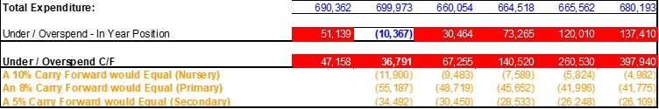
Deficit at the end of 23/24
Deficit at the end of 24/25
The in-year positon is -£10,367 meaning we would have ‘paid back’ this amount against our deficit from 23/24.
However, following discussions with parents over the recent weeks, it has come to our attention that 2 children in Year 1 will be leaving. One due to a relocation and another due to wanting a larger school. This family has an older sibling but no place at WSH for them at the moment, as far as we’re aware the older child will remain with us only until a place becomes available.
As we are so number sensitive and the lack of a Reception year, ZL contacted the Locality Lead to see what her thoughts were. She was very clear that if there was an opportunity to ‘stabilise the ship’ and repay the debt this had to be the first option, anything else could be termed as financial mismanagement. We would have difficulty justifying to LCC a significant deficit at the end of 24/25, which would then have a huge knock on effect going into 25/26 and future years. The fourth class was only budgeted for until 31.08.25 anyway and we’d have to review again. Following an emergency Governor meeting on 08.05.24, the budget presented today for approval is for 3 classes.
For Governor Approval – 14.05.2024

Deficit at the end of 23/24 Deficit at the end of 24/25
Deficit at the end of 25/26
This option still gives a slight deficit but with the potential EHCP funding we’re hoping to receive, we should hopefully break even at the end of 24/25.
The class structures would be as follows:
Class 1 – YR, 1 & 2 – 22 children (8 spaces for any mid-year admissions)
Class 2 – Y3 & 4 – 24 children (6 spaces for any mid-year admissions)
Class 3 – Y5 & Y6 – 32 children (0 spaces for any mid-year admissions)
We have the scope and capacity for TA’s to take their 1:1’s out of the classroom if needs be and there is also the possibility of starting a Preschool class with the additional space. A project we’d like to see up and running to aid in boosting out future numbers.
We appreciate going to 3 classes isn’t the decision we wanted to make as a school and there is a fine balance between financial, educational and wellbeing of children of staff but we also have to see the positives that can come from this and move the school forward.

Summary Page
Graphs
The following graphs have been taken from the MTFP Dashboard.
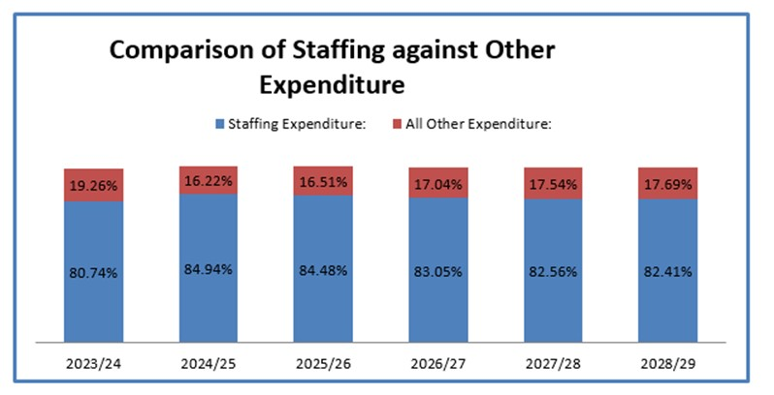
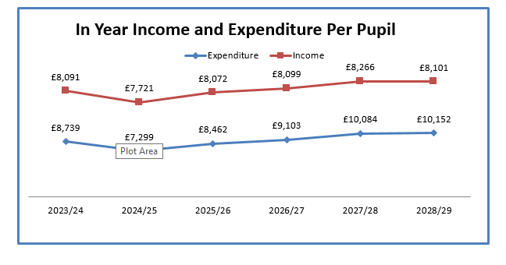

Pupil Numbers
Teaching Staff
Any pay increases & overtime for teachers have been built into the plan
Non-Teaching Staff
Any pay increases & overtime for support staff have been built into the plan.
Grants
Grants have been utilised, where possible, to take the pressure off the main budget.
Devolved Capital
New lights are due to be fitted throughout school during the summer holidays. These will be fully funded from Devolved.
New figures for 24/25 yet to be released.

