
Swinderby All Saints Primary School
Governor Finance Report – July 2024
Financial Plan for 24/25
The MTFP was sent to School’s Finance following the approval from Governors, we now wait whilst they carry out their high level reviews and upload the information into BW during the summer. If (when) we trigger the Monitoring and Intervention for 24/25 we will be notified during the summer holidays and from September we can then start forecasts again.
Governor Approved – 14.05.2024

Deficit at the end of 23/24 Deficit at the end of 24/25
Deficit at the end of 25/26
Adam Emson (the School’s Finance officer) who worked with ZL and TS in April has been allocated to work on our plan with the current M&I and has been very thorough looking over our current 24/25 plan and gave TS some work to do ahead of sending back to him to check again. This work was completed 26.06.24. We are also due to book another 1:1 meeting with him before 31.03.25 as part of our Silver package.
Aside from work School’s Finance has asked us to carry out, there have been some changes made due to circumstances in school.
- A child with an EHCP will be leaving us at the end of this term as they have a place in a special school. Their funding has been removed from the plan from Aug ’23. The TA associated with this child, we have decided to keep on due to the on-going need in school. However, their contract has been amended from 30.83hrs to 27.5hrs per week.
- 4 children have moved schools during this term: 1 due to a home relocation, 2 to Witham St Hughs and 1 to Bassingham.
- A child in Class 3 has had some behavioural challenges and in order for the classroom to manage it has been essential that a full time TA is placed to work with this child to keep disruption to an absolute minimum. We have trialled this and had 2 TA’s sharing the full time role on a relief basis. However, this may be something we have to continue in the future but we have the available TA at 27.5 hours from September.
- EHCP funding has finally be granted for Child E. A TA has been in place for some time now so it’s great to be able to finally add in some profound funding. It has been agreed that funding will be back date to 15.05.24.
- We have had to increase a 1:1 MMSA contract by 15mins per day because with them leaving at 12:45 meant there was a time when a 1:1 TA was with 2 children and it was becoming a struggle. We couldn’t have asked the MMSA to arrive 15mins later as they help setup the hall and this is already a struggle to get finished before the children arrive to eat.
With these adjustments the budget now looks as follows:
Deficit at end of 24/25
Deficit at the end of 25/26
The in-year positon for 24/25 is -£40,424 meaning we would have ‘paid back’ this amount against our deficit from 23/24.
We have had some long term staff sickness recently and now with the new 24/25 sickness template available from School’s Finance, we can claim for some of this absence. This should help to reduce the £6k a little further.
Graphs
The following graphs have been taken from the MTFP Dashboard.
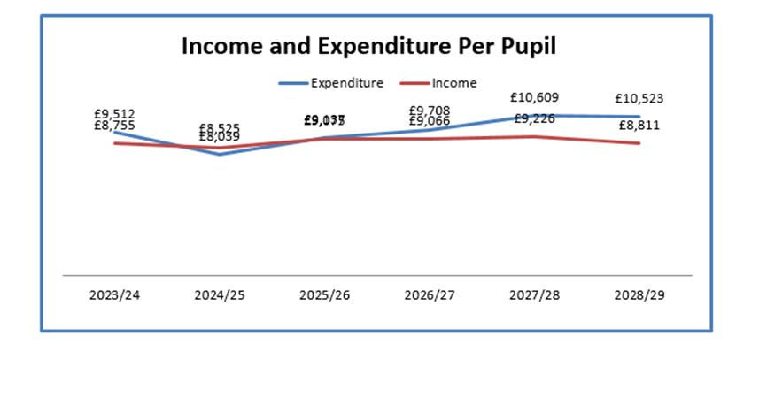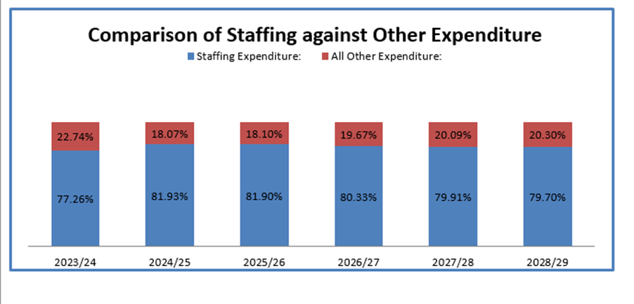
Summary Page
Pupil Numbers
We have had an enquiry for 2 mid-year admissions for September. A family is moving to Witham and would like space in Y2 and Y5 from September. They have asked for the places to be reserved, but unfortunately we can’t do this. ZL has confirmed the procedure and offered the family a visit on 15.07.24 but it depends if Mum accepts the house that is being offered. They will be relocating from Grimsby. We have received the mid-year admissions and had confirmation of 1 as having a place in Y5 in September. The younger sibling we believe may have been accepted at Witham. There is also the possibility that the EHE child may be returning in September following a call to mum by ZL to check. Waiting to hear further before any amendments to plan.
Teaching Staff
Any pay increases & overtime for teachers have been built into the plan
Non-Teaching Staff
Any pay increases & overtime for support staff have been built into the plan.
Grants
Grants have been utilised, where possible, to take the pressure off the main budget. Future years still need work for some of the grants
Devolved Capital
New lights are due to be fitted throughout school during the summer holidays. These will be fully funded from Devolved.
Allocation for 24/25 is confirmed as £4,934 plus a carry forward from 23/24 of £661 giving us a total of £5,595 for the year.

